# VISVESVARAYA TECHNOLOGICAL UNIVERSITY

**“JnanaSangama”, Belgaum -590014, Karnataka.**



## LAB REPORT

### on

Object Oriented Java Programming (23CS3PCOOJ)

#### Submitted by

**Anagha D K (1BM23CS032)**

#### in partial fulfillment for the award of the degree of

**BACHELOR OF ENGINEERING**

***in***

## COMPUTER SCIENCE AND ENGINEERING



**B.M.S. COLLEGE OF ENGINEERING**

**(Autonomous Institution under VTU)**

## BENGALURU-560019

### Sep-2024 to Jan-2025

**B.M.S. College of Engineering,**

**Bull Temple Road, Bangalore 560019**

(Affiliated To Visvesvaraya Technological University, Belgaum)

**Department of Computer Science and Engineering**



##### CERTIFICATE

This is to certify that the Lab work entitled “Object Oriented Java Programming (23CS3PCOOJ)” carried out by Anagha D K **(1BM23CS032),** who is bonafide student of **B.M.S. College of Engineering.** It is in partial fulfillment for the award of **Bachelor of Engineering in Computer Science and Engineering** of the Visvesvaraya Technological University, Belgaum. The Lab report has been approved as it satisfies the academic requirements in respect of an Object Oriented Java Programming (23CS3PCOOJ) work prescribed for the said degree.

**Dr. Jyothi S Nayak**

Professor & HOD

Department of CSE, BMSCE

Lab faculty Incharge Name Dr. **Basavaraj Jakkali**

Assistant Professor Department of CSE, BMSCE

# Index

|  |  |  |  |
| --- | --- | --- | --- |
| **Sl.**  **No.** | **Date** | **Experiment Title** | **Page No.** |
| 1 | 09-10-24 | Quadratic Implementation | 4-9 |
| 2 | 16-10-24 | Calculation of SGPA | 10-19 |
| 3 | 23-10-24 | Input and display of book details | 20-25 |
| 4 | 23-10-24 | Finding areas of various shapes using Abstract Class | 26-32 |
| 5 | 30-10-24 | Finding Compound Interest | 32-45 |
| 6 | 13-11-24 | Finding CIE and SEE marks using packages | 45-56 |
| 7 | 20-11-24 | Exception Handling | 56-64 |
| 8 | 27-11-24 | Implementation of Threads | 64-70 |
| 9 | 27-11-24 | Division app | 70-77 |
| 10 | 27-11-24 | Demonstrate inter process communication and Deadlock | 77-88 |

Github Link:

##### <https://github.com/anaghadk/Java-Lab/tree/main>

##### Program 1

Implement Quadratic Equation

Observations:

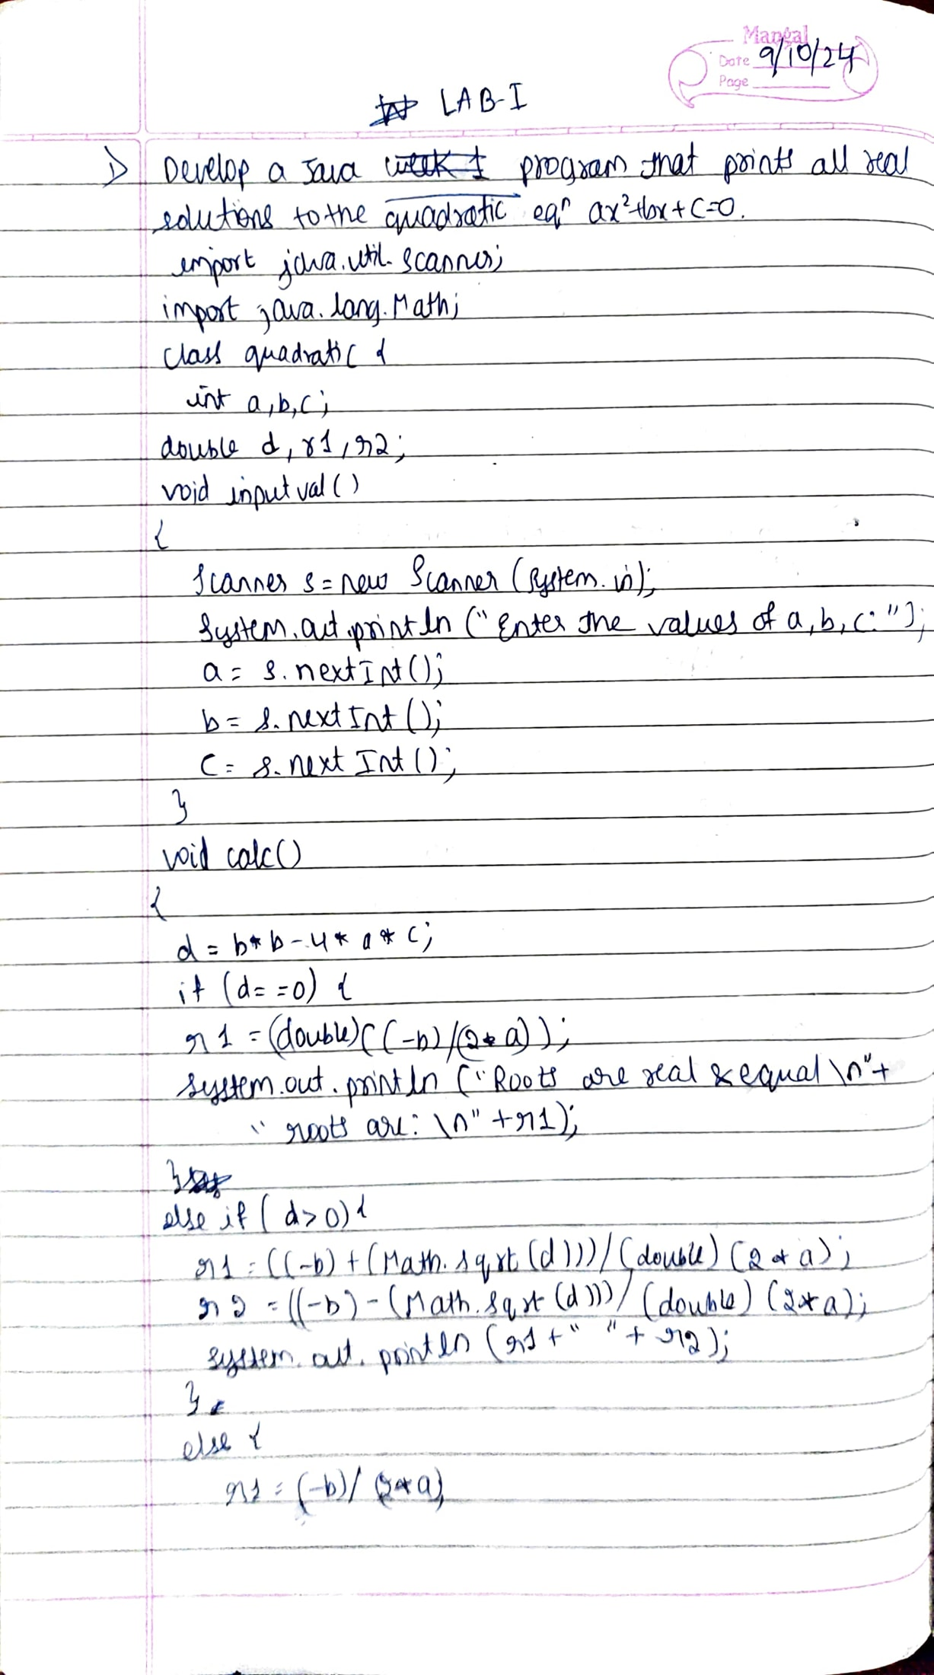



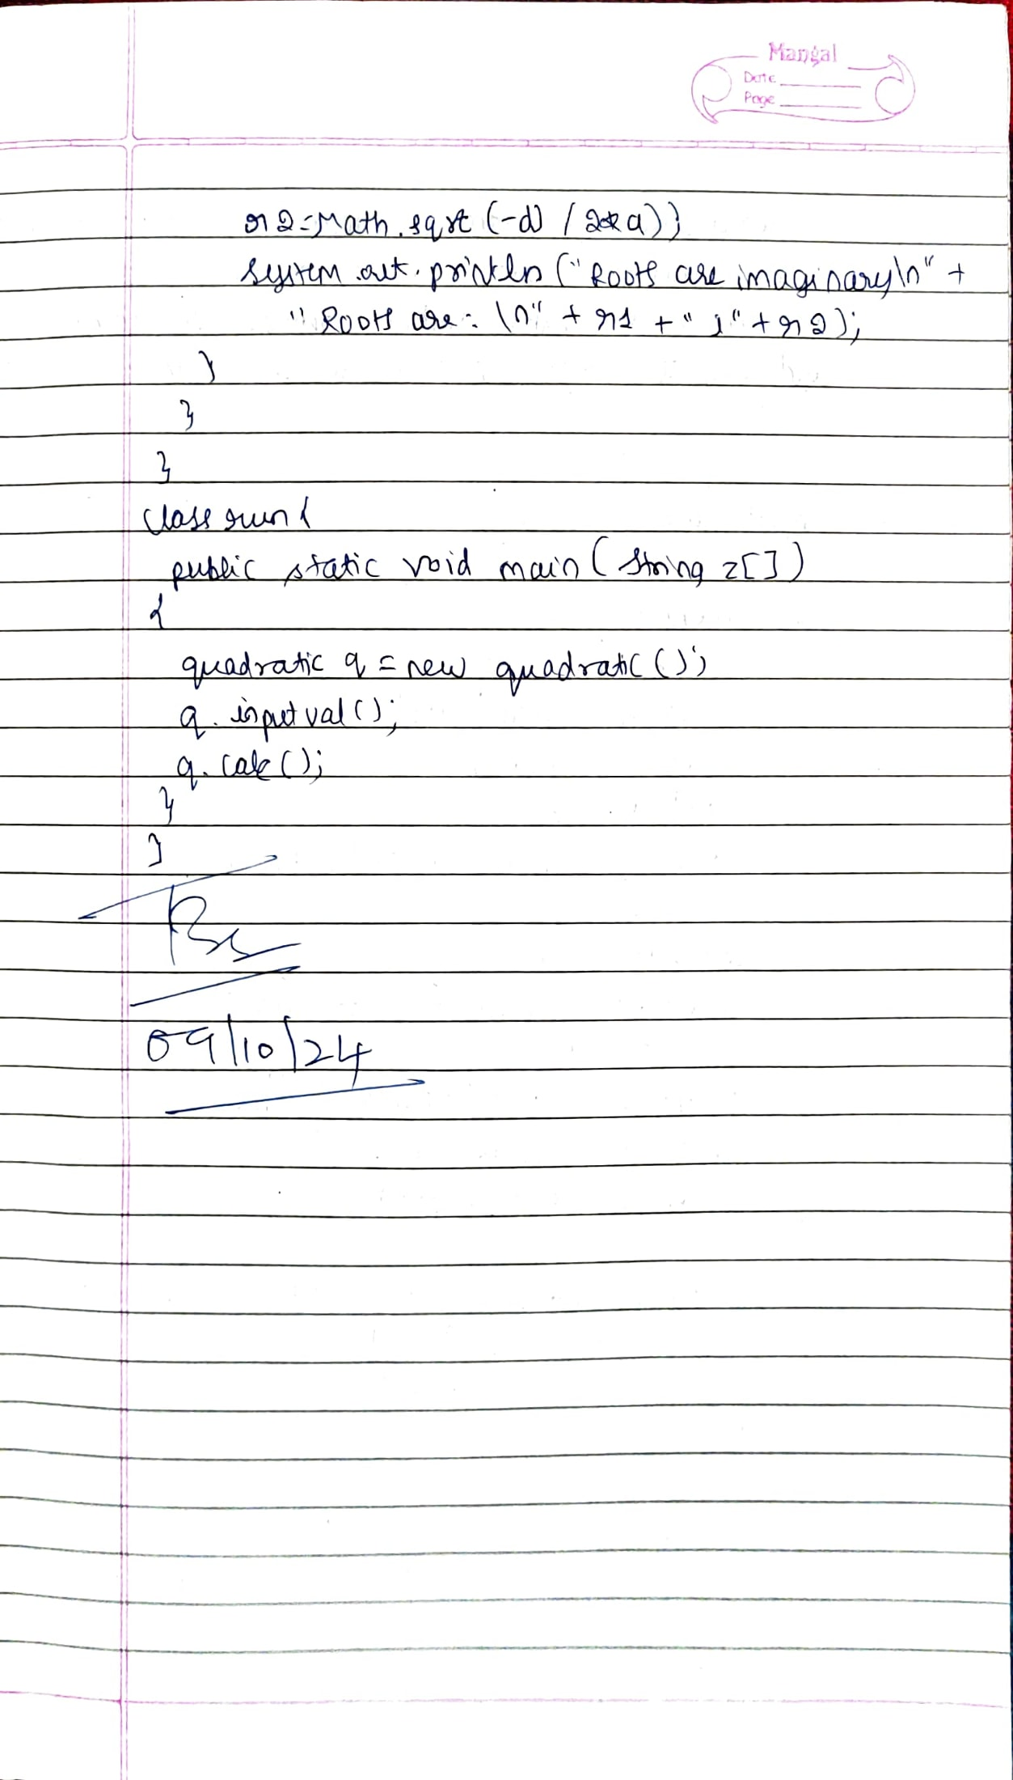

Code:

import java.util.Scanner;

import java.lang.Math;

class quadratic {

int a,b,c;

double d,r1,r2;

void inputval()

{

Scanner s=new Scanner(System.in);

System.out.println("Enter the values of a");

a=s.nextInt();

while(a==0) {

System.out.println("Enter the values of a");

a=s.nextInt();

}

System.out.println("Enter the values of b");

b=s.nextInt();

System.out.println("Enter the values of c");

c=s.nextInt();

}

void calc()

{

d=b*b-4*a*c;

if(d==0) {

r1=(double)((-b)/(2*a));

System.out.println("Roots are real and equal\n"+"Roots are: \n"+r1);

}

else if(d>0) {

r1=((-b)+(Math.sqrt(d)))/(double)(2*a);

r2 =((-b)-(Math.sqrt(d)))/(double)(2*a);

System.out.println(r1+" "+r2);

}

else {

r1 =(-b)/(2*a);

r2=Math.sqrt(-d)/(2*a);

System.out.println("Roots are imaginary\n"+"Roots are: \n"+r1+" i "+r2);

}

}

}

class run {

public static void main(String z[])

{

quadratic q=new quadratic();

q.inputval();

q.calc();

}

}

Output:

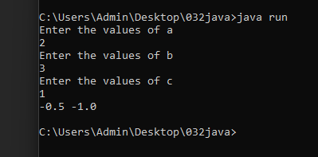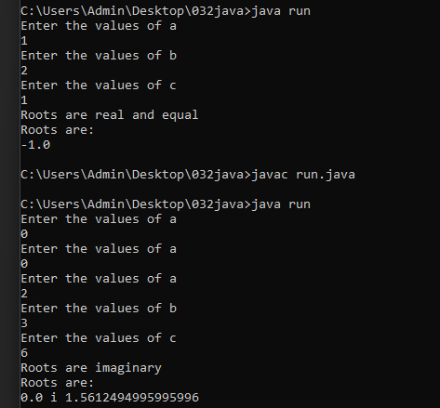

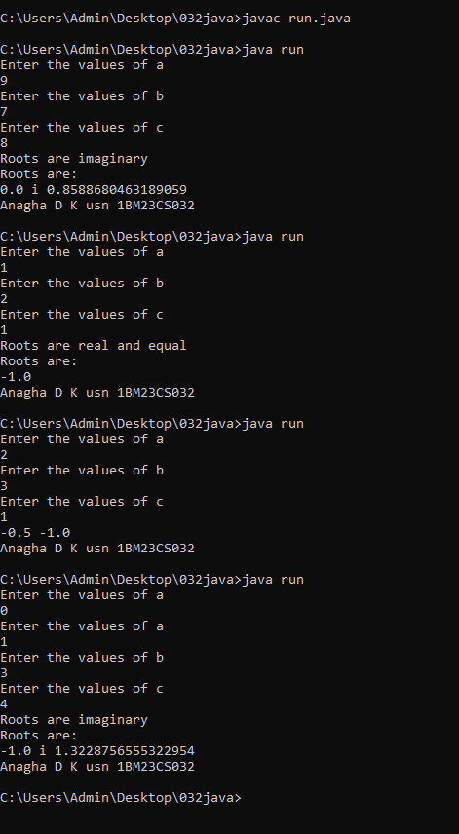

##### Program 2

Develop a Java program to create a class Student with members usn, name, an array credits and an array marks. Include methods to accept and display details and a method to calculate SGPA of a student.

Observations:

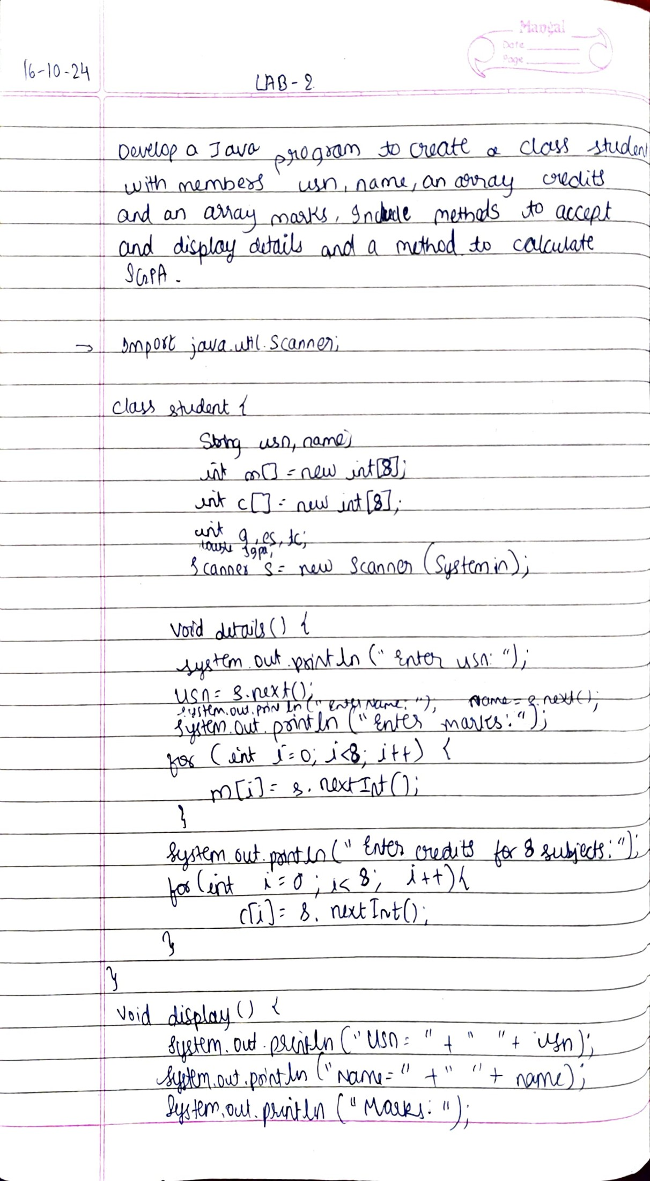



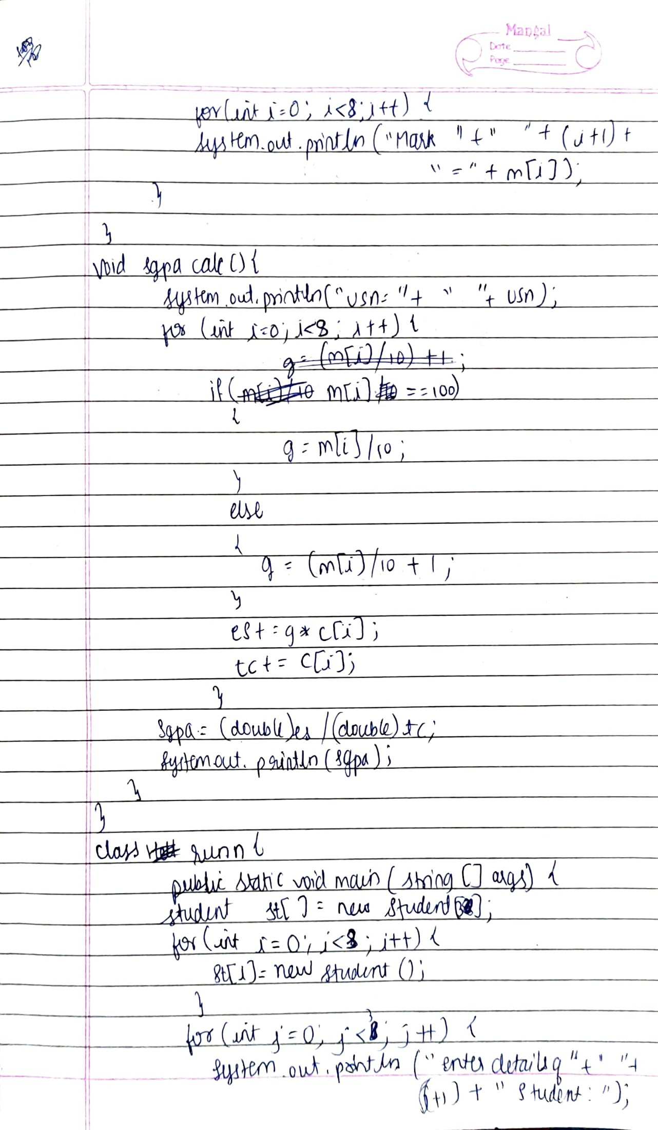

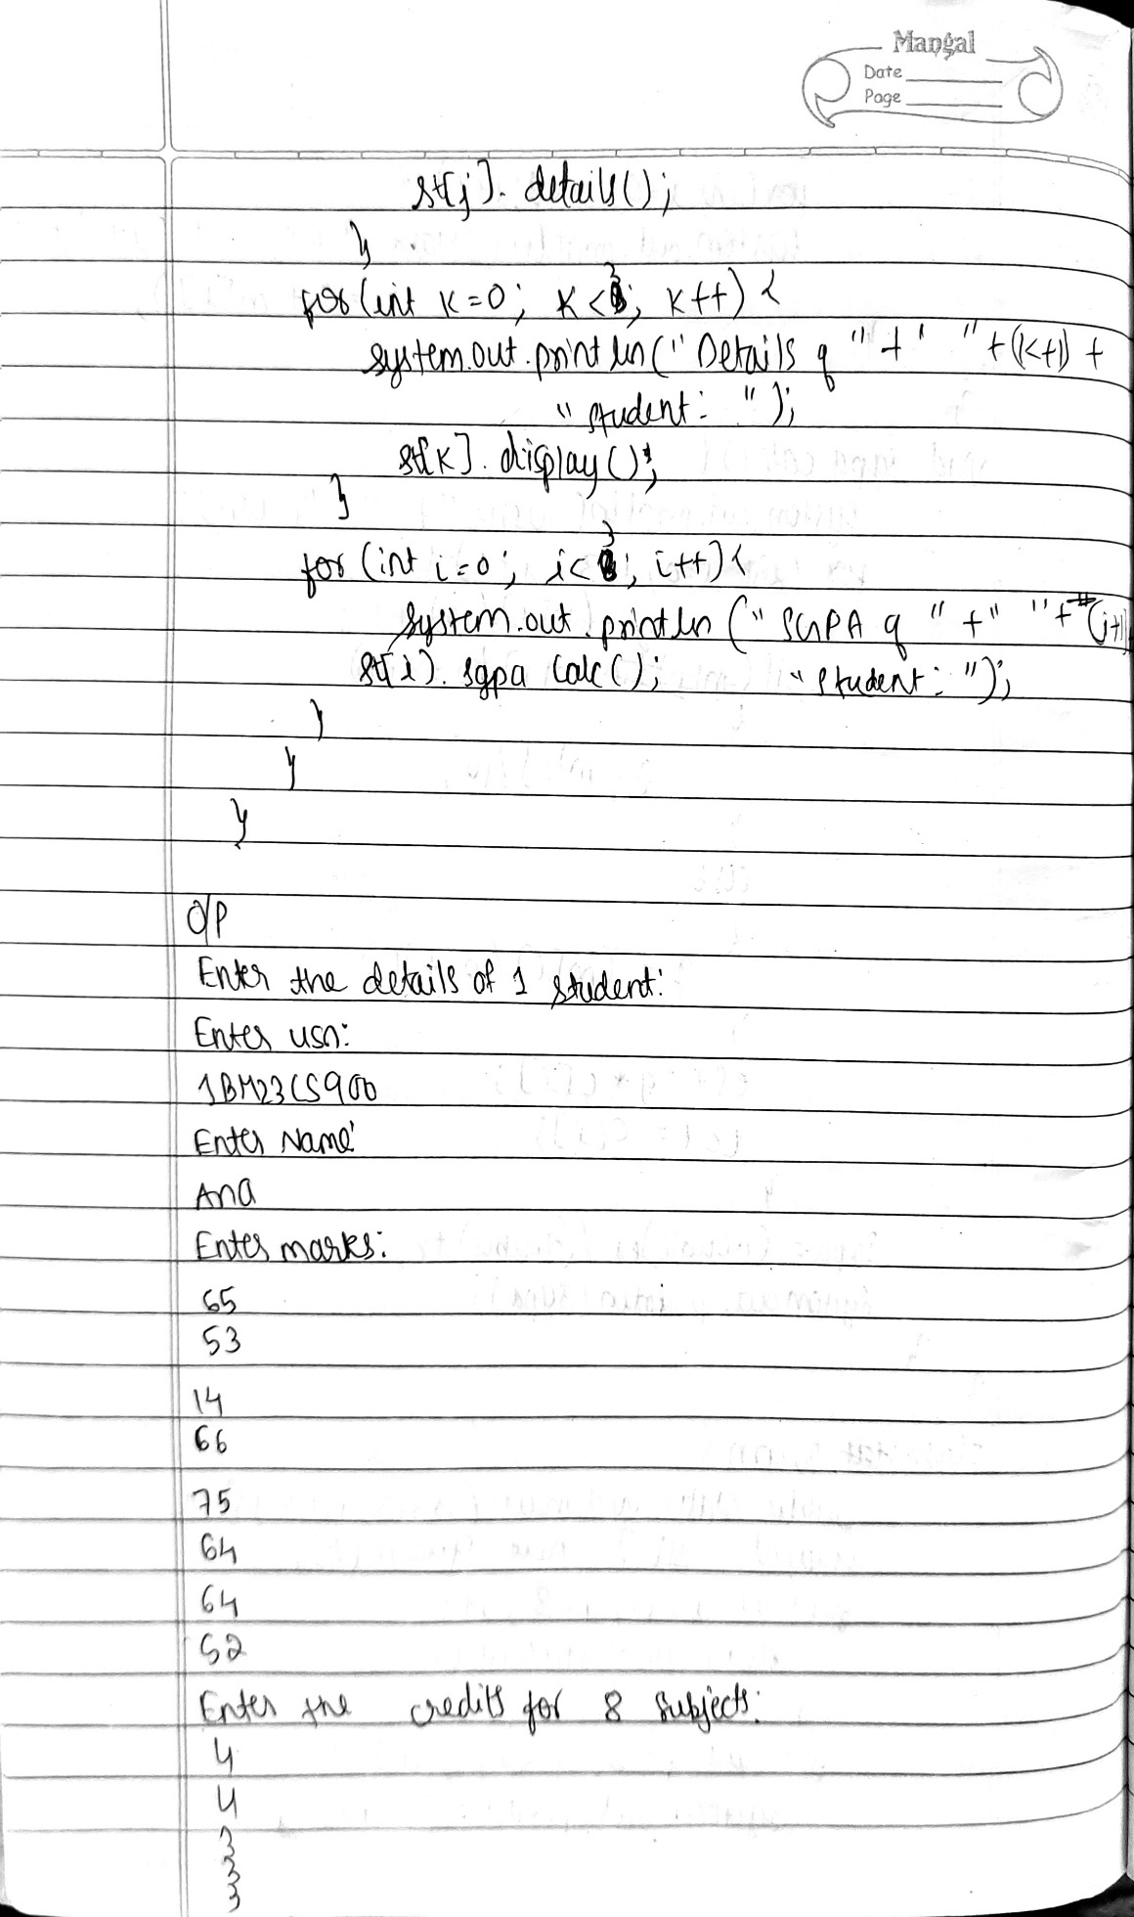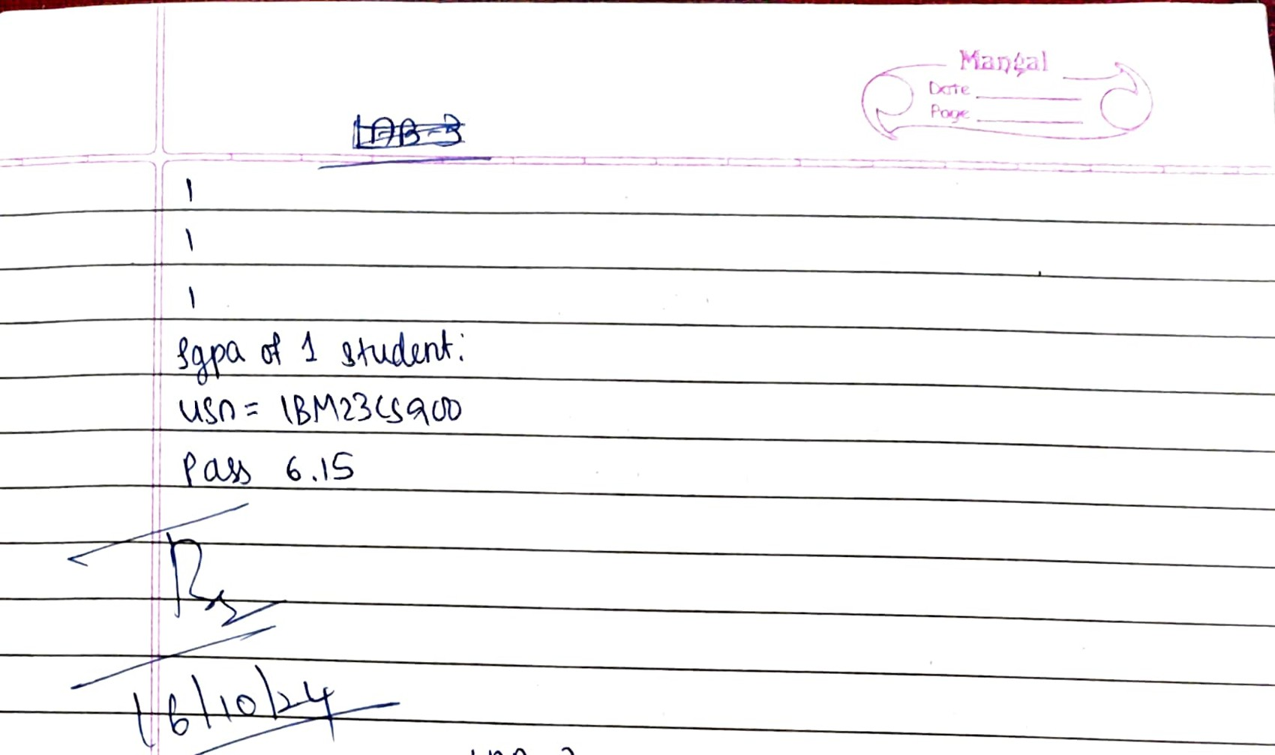

Code:

import java.util.Scanner;

class student{

String usn, name;

int m[]=new int[8];

int c[]=new int[8];

int g, es, tc;

double sgpa;

Scanner s=new Scanner(System.in);

void details() {

System.out.println("Enter usn: ");

usn=s.next();

System.out.println("Enter Name: ");

name=s.next();

System.out.println("Enter marks: ");

for(int i=0;i<8;i++) {

m[i]=s.nextInt();

}

System.out.println("Enter the credits for 8 subjects: ");

for(int i=0;i<8;i++) {

c[i]=s.nextInt();

}

}

void display() {

System.out.println("usn= "+" "+usn);

System.out.println("Name= "+" "+name);

System.out.println("Marks= ");

for(int i=0;i<8;i++) {

System.out.println("Marks of "+" "+(i+1)+" = "+m[i]);

}

}

void sgpacalc() {

System.out.println("usn= "+" "+usn);

for(int i=0;i<8;i++) {

if(m[i]==100) {

g=m[i]/10;

}

else {

g=(m[i]/10)+1;

}

es+=g*c[i];

tc+=c[i];

}

sgpa=(double)es/(double)tc;

if(sgpa<=4) {

System.out.println("Fail"+" "+sgpa);

}

else {

System.out.println("Pass"+" "+sgpa);

}

}

}

class runn {

public static void main(String z[]) {

System.out.println("Anagha D K, 1BM23CS032 ");

student st[]=new student[3];

for(int i=0;i<3;i++) {

st[i]=new student();

}

for(int j=0;j<3;j++) {

System.out.println("Enter the details of"+" "+(j+1)+" Student: ");

st[j].details();

}

for(int k=0;k<3;k++) {

System.out.println("Details of: "+" "+(k+1)+" Student: ");

st[k].display();

}

for(int i=0;i<3;i++) {

System.out.println("sgpa of: "+" "+(i+1)+" Student: ");

st[i].sgpacalc();

}

}

}

Output:

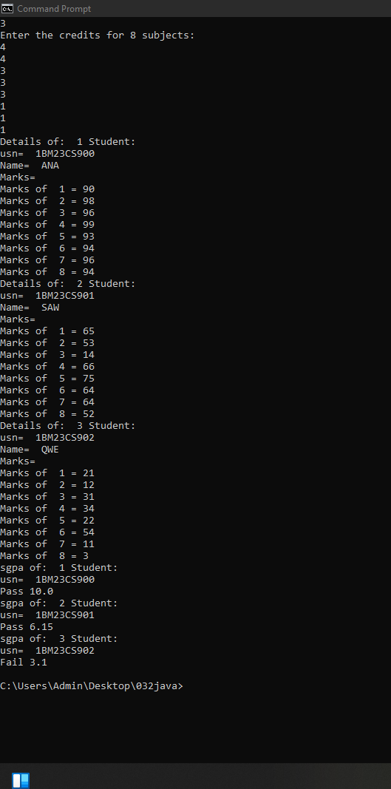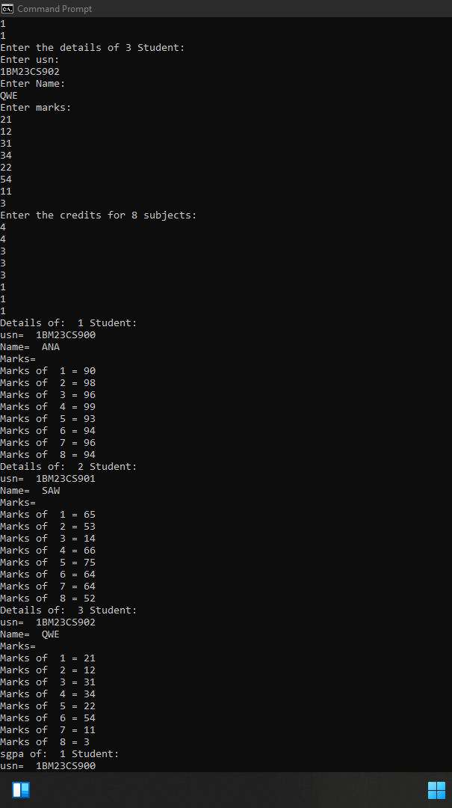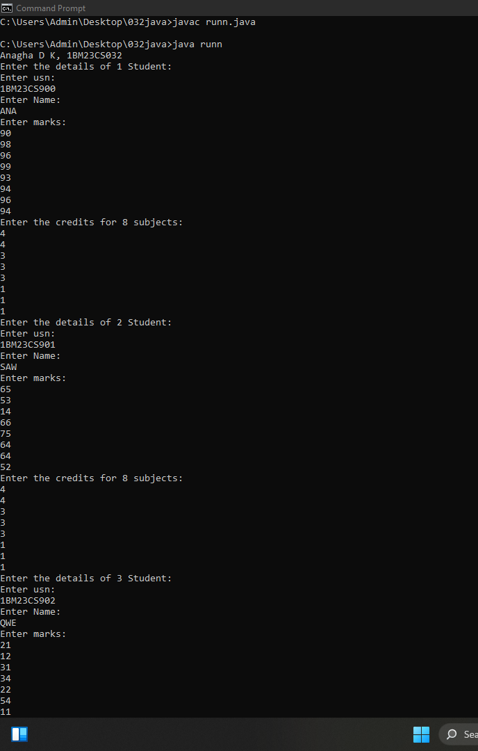

Program 3

Create a class Book which contains four members: name, author, price, num_pages. Include a constructor to set the values for the members. Include methods to set and get the details of the objects. Include a toString( ) method that could display the complete details of the book. Develop a Java program to create n book objects.

Observations:

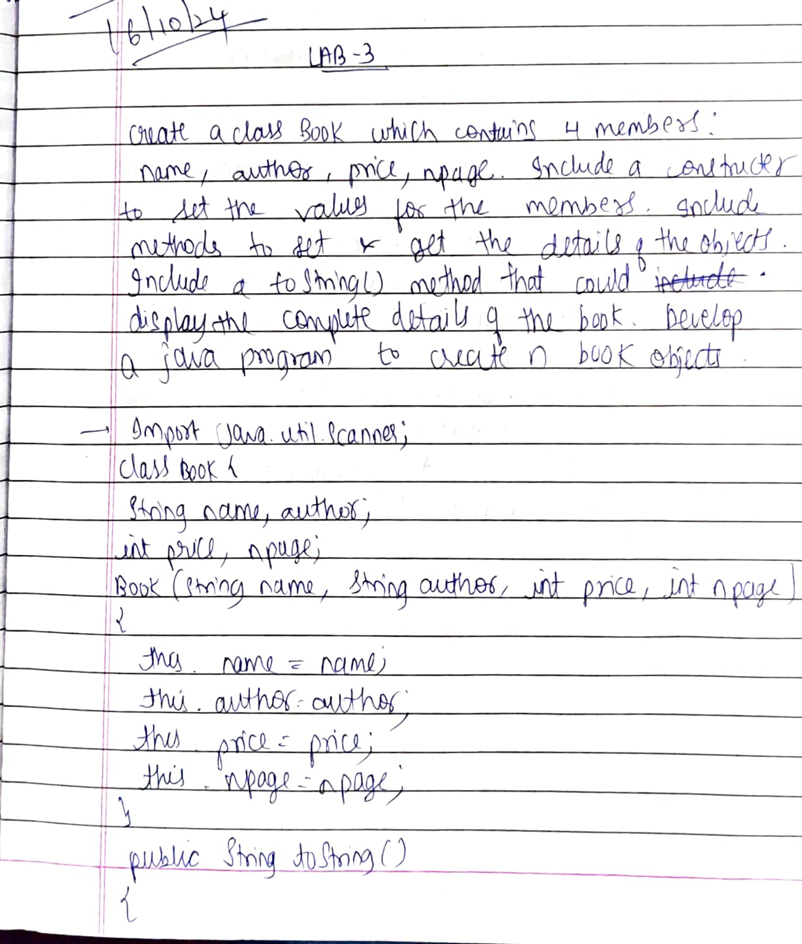

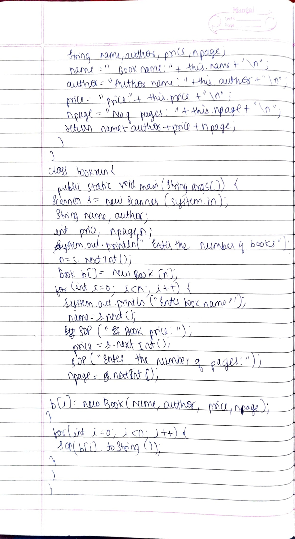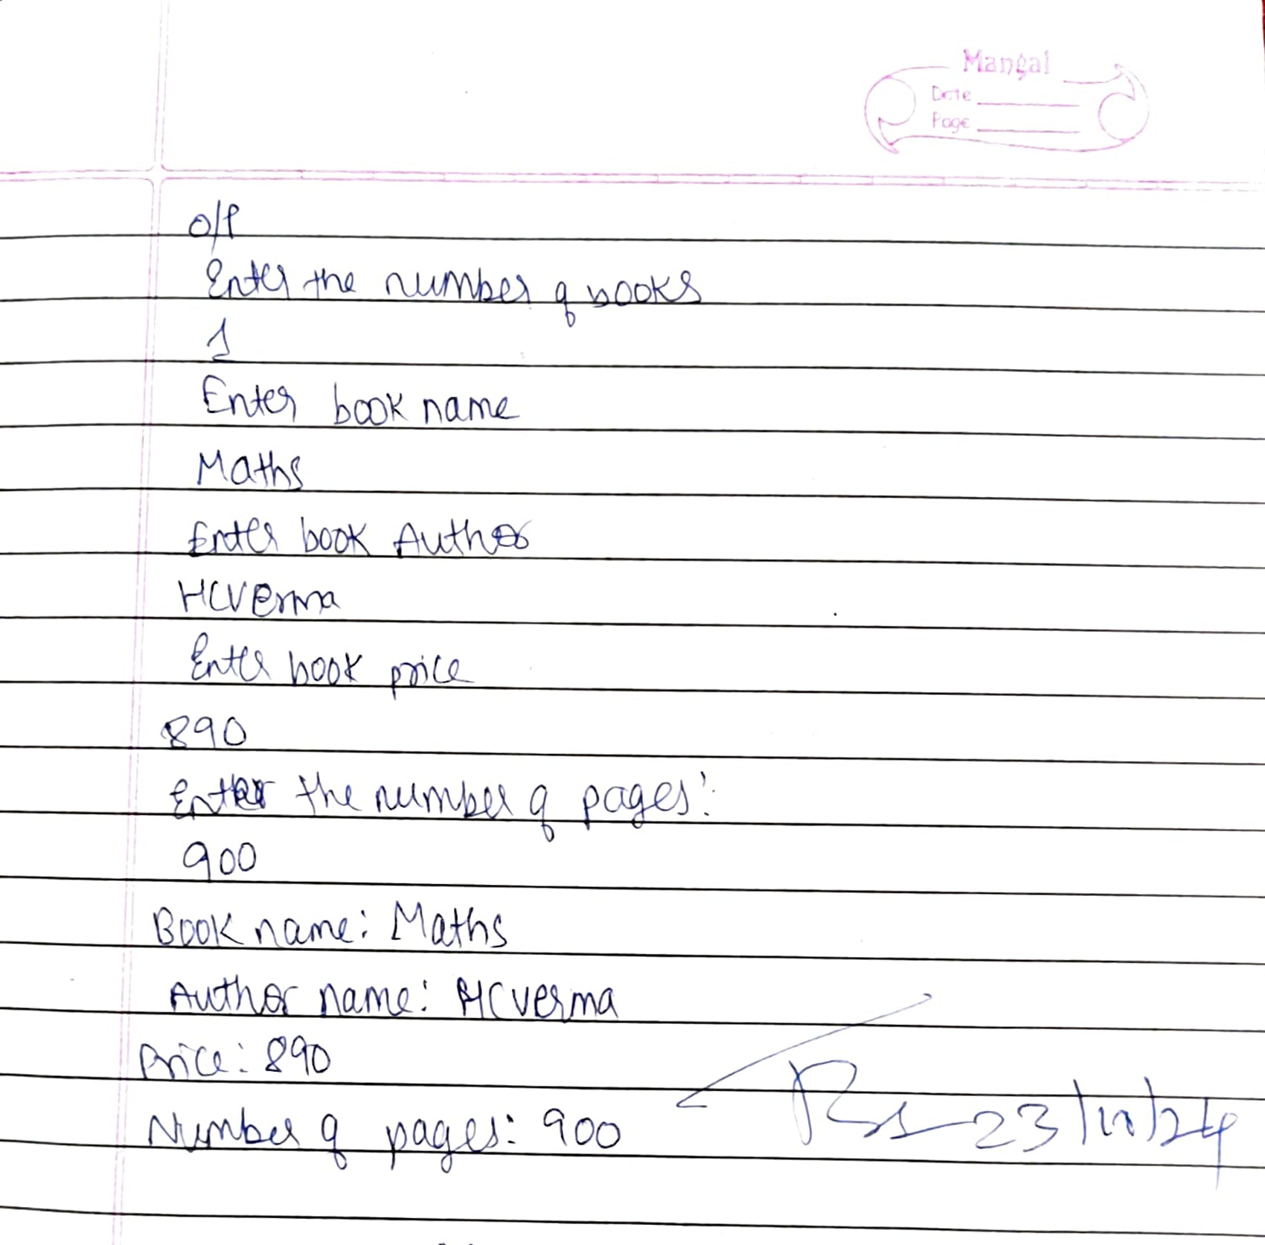

Code:

import java.util.Scanner;

class Book {

String name, author;

int price, npage;

Book(String name, String author, int price, int npage)

{

this.name=name;

this.author=author;

this.price=price;

this.npage=npage;

}

public String toString()

{

String name, author,price,npage;

name = "Book name: "+this.name+"\n";

author = "Author name:"+this.author+"\n";

price = "Price: " +this.price+"\n";

npage = "Number of pages: "+this.npage+"\n";

return name+author+price+npage;

}

}

class bookrun {

public static void main(String args[]) {

Scanner s=new Scanner(System.in);

String name, author;

int price, npage;

int n;

System.out.println("Enter the number of books");

n=s.nextInt();

Book b[]=new Book[n];

for(int i=0;i<n;i++) {

System.out.println("Enter book name");

name=s.next();

System.out.println("Enter book Author");

author=s.next();

System.out.println("Enter book price");

price=s.nextInt();

System.out.println("Enter the number of pages of the book ");

npage=s.nextInt();

b[i]=new Book(name,author,price,npage);

}

for(int i=0;i<n;i++) {

System.out.println(b[i].toString());

}

}

}

Output:

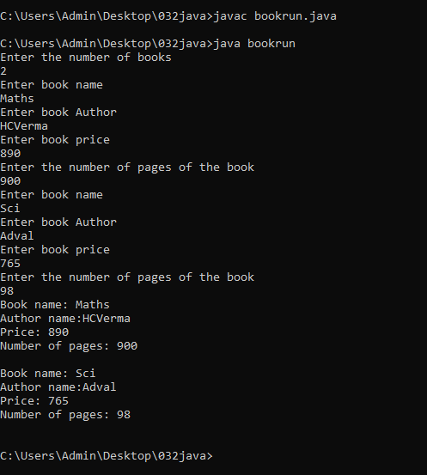

**Program 4**

Develop a Java program to create an abstract class named Shape that contains two integers and an empty method named printArea( ). Provide three classes named Rectangle, Triangle and Circle such that each one of the classes extends the class Shape. Each one of the classes contain only the method printArea( ) that prints the area of the given shape.

Observations:

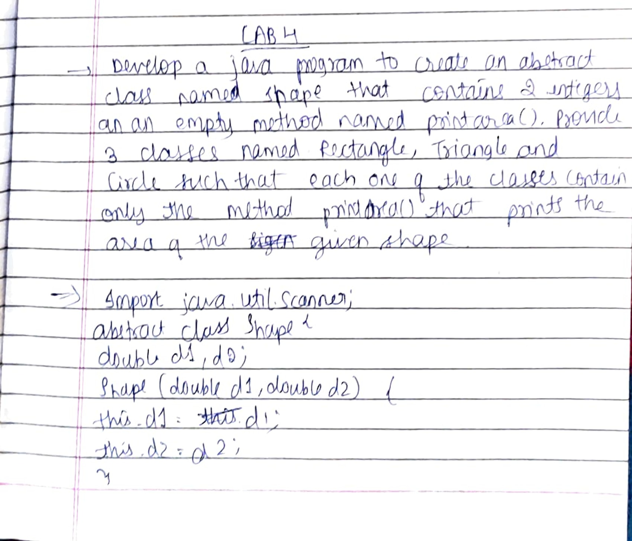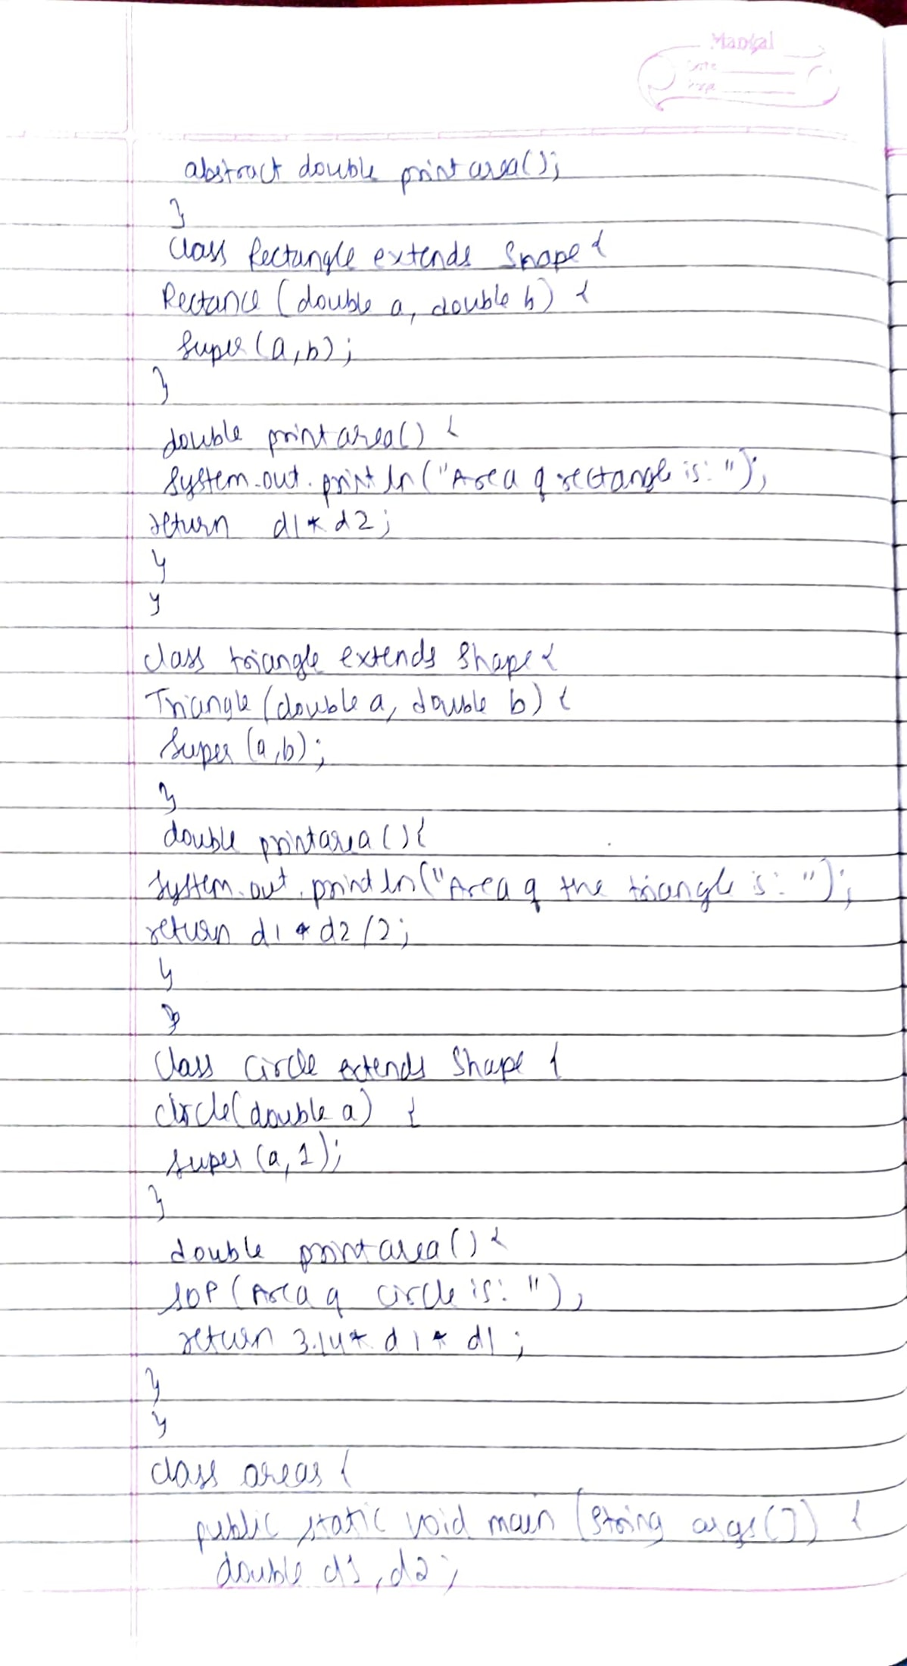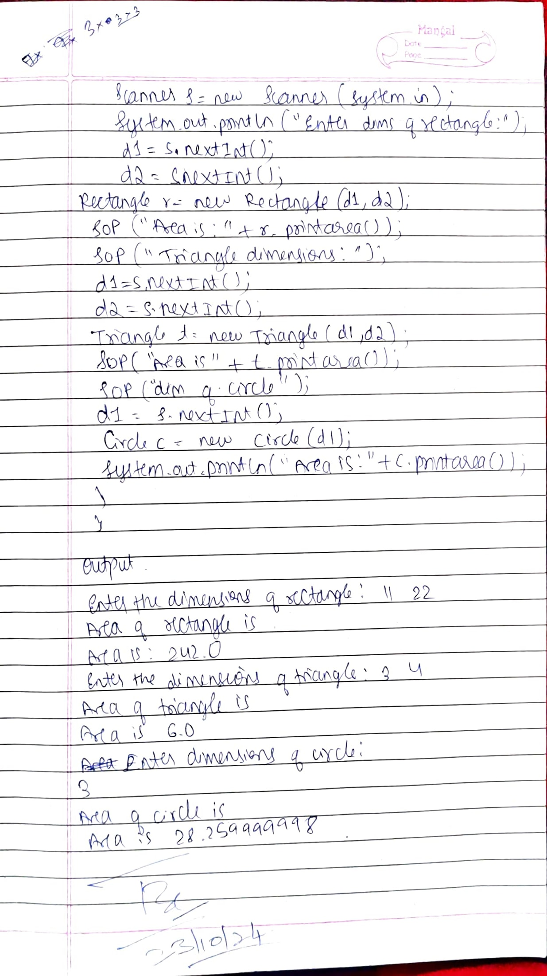

Code:

import java.util.Scanner;

abstract class Shape {

double d1,d2;

Shape(double d1,double d2) {

this.d1=d1;

this.d2=d2;

}

abstract double printarea();

}

class Rectangle extends Shape {

Rectangle(double a,double b) {

super(a,b);

}

double printarea() {

System.out.println("Area of the rectangle is: ");

return d1*d2;

}

}

class Triangle extends Shape {

Triangle(double a,double b) {

super(a,b);

}

double printarea() {

System.out.println("Area of the Triangle is: ");

return d1*d2/2;

}

}

class Circle extends Shape {

Circle(double a) {

super(a,1);

}

double printarea() {

System.out.println("Area of the circle is: ");

return 3.14*d1*d1;

}

}

class areas {

public static void main(String args[]) {

double d1,d2;

Scanner s=new Scanner(System.in);

System.out.println("Enter the dimensions of the rectangle:");

d1=s.nextInt();

d2=s.nextInt();

Rectangle r = new Rectangle(d1,d2);

System.out.println("Area is :"+r.printarea());

System.out.println("Enter the dimensions of the Triangle:");

d1=s.nextInt();

d2=s.nextInt();

Triangle t = new Triangle(d1,d2);

System.out.println("Area is :"+t.printarea());

System.out.println("Enter the dimensions of the Circle:");

d1=s.nextInt();

Circle c = new Circle(d1);

System.out.println("Area is :"+c.printarea());

}

}

Output:

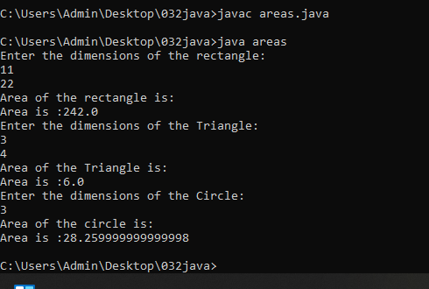

**Program 5**

Develop a Java program to create a class Bank that maintains two kinds of account for its customers, one called savings account and the other current account. The savings account provides compound interest and withdrawal facilities but no cheque book facility. The current account provides cheque book facility but no interest. Current account holders should also maintain a minimum balance and if the balance falls below this level, a service charge is imposed. Create a class Account that stores customer name, account number and type of account. From this derive the classes Cur-acct and Sav-acct to make them more specific to their requirements. Include the necessary methods in order to achieve the following tasks:

a)Accept deposit from customer and update the balance.

b)Display the balance.

c)Compute and deposit interest

d)Permit withdrawal and update the balance

e) Check for the minimum balance, impose penalty if necessary and update the balance.

Observations:

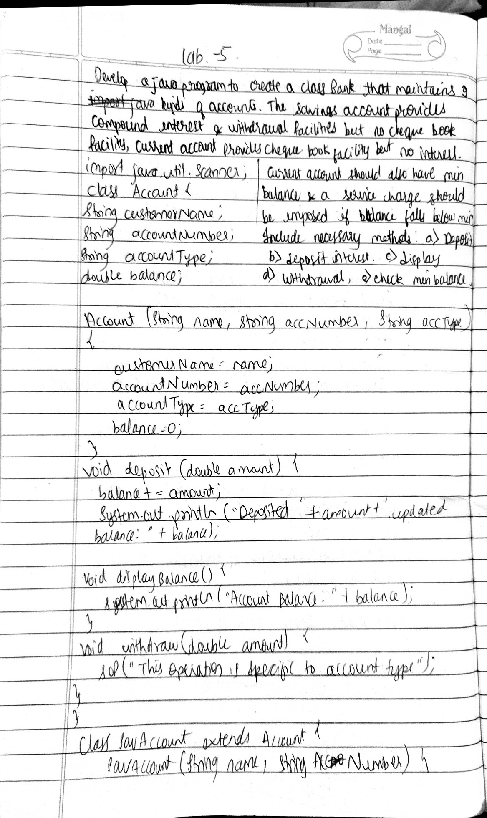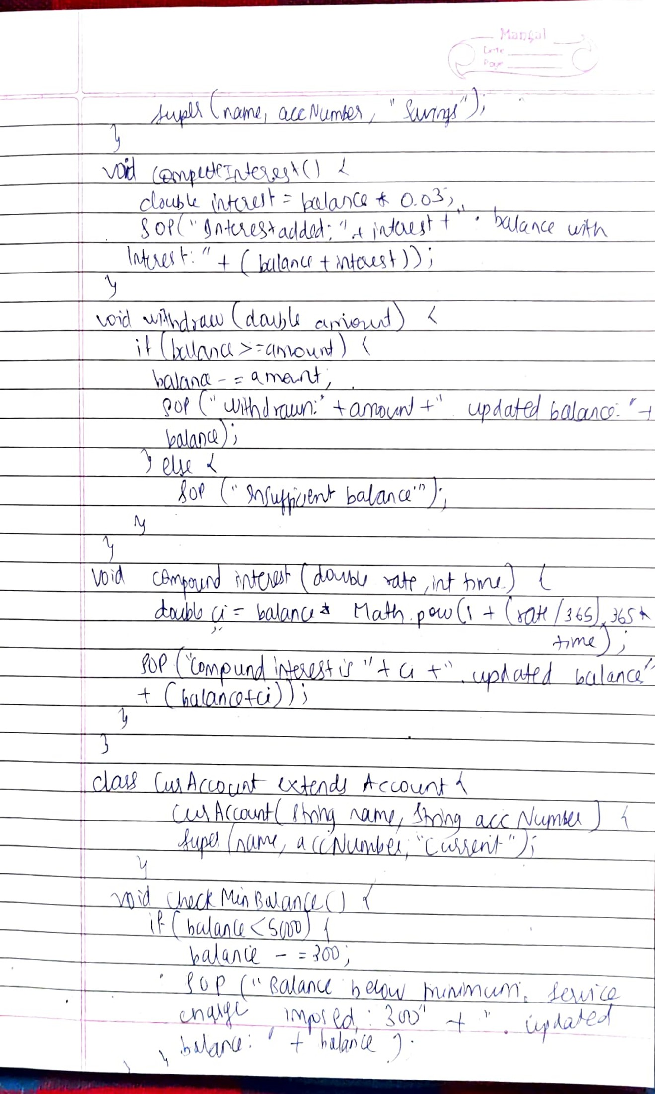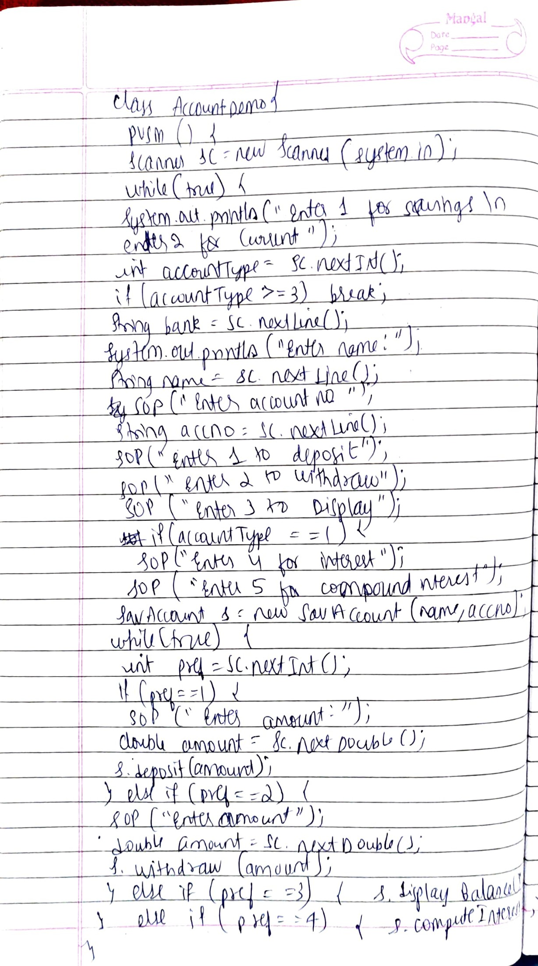

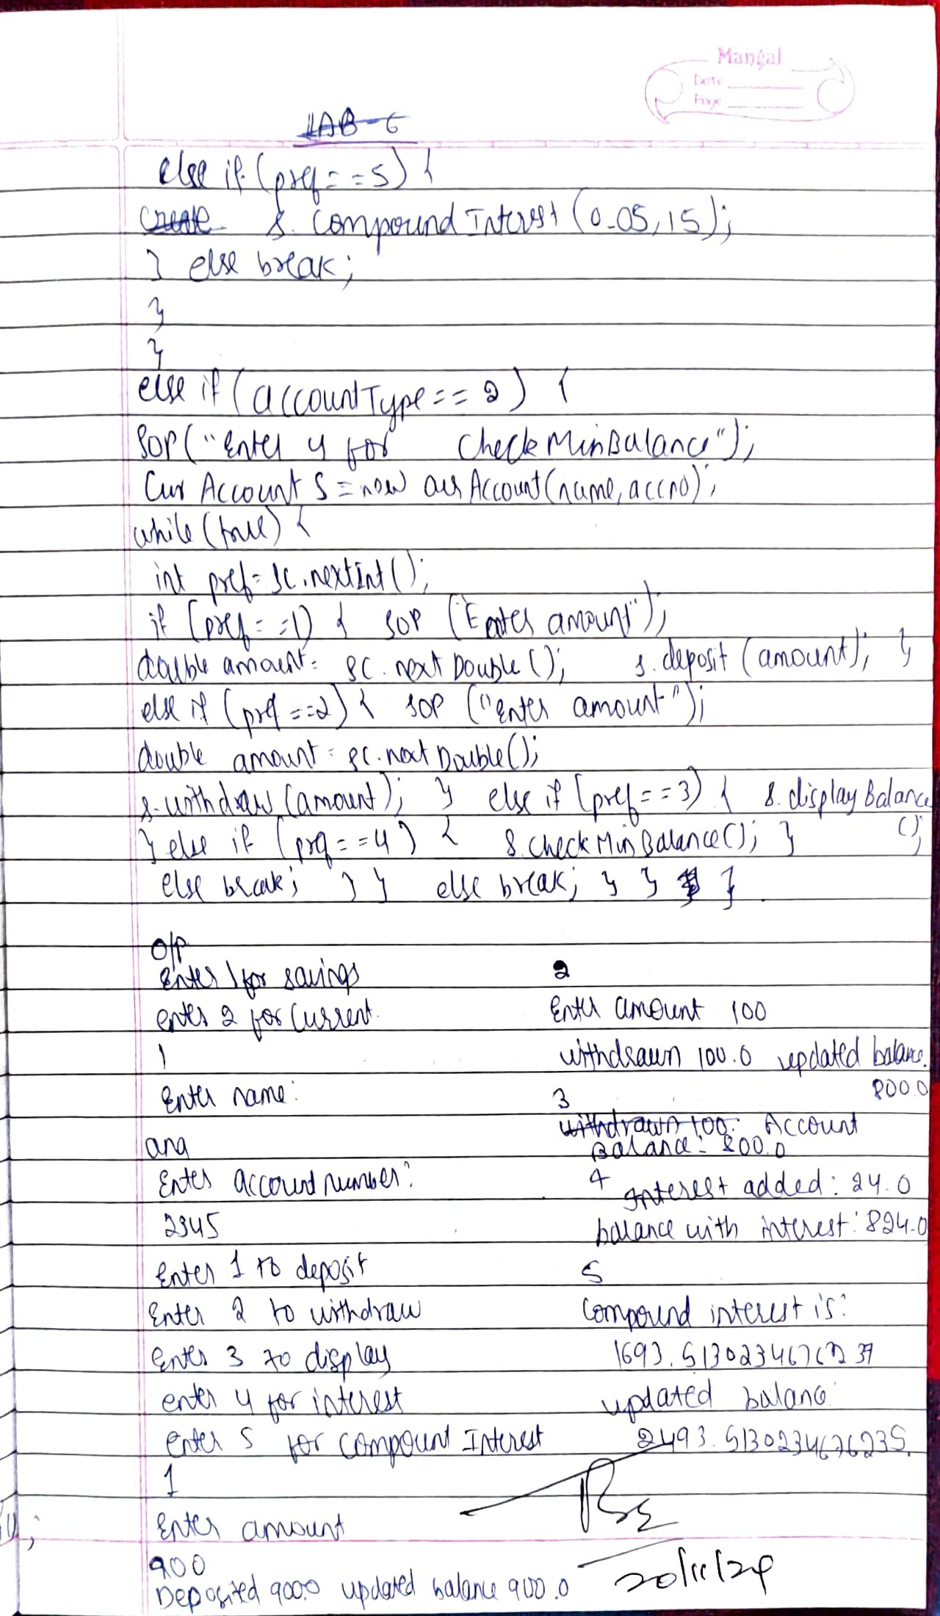

Code:

import java.util.Scanner;

class Account {

String customerName;

String accountNumber;

String accountType;

double balance;

Account(String name, String accNumber, String accType) {

customerName = name;

accountNumber = accNumber;

accountType = accType;

balance = 0;

}

void deposit(double amount) {

balance += amount;

System.out.println("Deposited: " + amount + ". Updated balance: " + balance);

}

void displayBalance() {

System.out.println("Account Balance: " + balance);

}

void withdraw(double amount) {

System.out.println("This operation is specific to account type.");

}

}

class SavAccount extends Account {

SavAccount(String name, String accNumber) {

super(name, accNumber, "Savings");

}

void computeInterest() {

double interest = balance * 0.03;

System.out.println("Interest added: " + interest + ". balance with interest: " + (balance+interest));

}

void withdraw(double amount) {

if (balance >= amount) {

balance -= amount;

System.out.println("Withdrawn: " + amount + ". Updated balance: " + balance);

} else {

System.out.println("Insufficient balance.");

}

}

void compoundInterest(double rate, int time) {

// Formula for compound interest

double ci = balance * Math.pow(1 + (rate / 365), 365 * time);

System.out.println("Compound Interest is: " + ci + ". Updated balance: " + (balance+ci));

}

}

class CurAccount extends Account {

CurAccount(String name, String accNumber) {

super(name, accNumber, "Current");

}

void checkMinBalance() {

if (balance < 5000) {

balance -= 300;

System.out.println("Balance below minimum. Service charge imposed: 300" + ". Updated balance: " + balance);

}

}

void withdraw(double amount) {

if (balance >= amount) {

balance -= amount;

System.out.println("Withdrawn: " + amount + ". Updated balance: " + balance);

checkMinBalance();

} else {

System.out.println("Insufficient balance.");

}

}

}

class AccountDemo {

public static void main(String[] args) {

Scanner sc = new Scanner(System.in);

while(true){

System.out.println("enter 1 for savings \n enter 2 for Current ");

int accountType = sc.nextInt();

if(accountType>=3) break;

String bank = sc.nextLine();

System.out.println("Enter the name : ");

String name = sc.nextLine();

System.out.println("Enter the Accout Number : ");

String accno = sc.nextLine();

System.out.println("Enter 1 to deposite");

System.out.println("Enter 2 to withdraw");

System.out.println("Enter 3 to Display");

if(accountType==1){

System.out.println("Enter 4 for Interest");

System.out.println("Enter 5 for Compound interest");

SavAccount s = new SavAccount(name,accno);

while(true){

int pref = sc.nextInt();

if(pref==1){

System.out.println("Enter the amount ");

double amount = sc.nextDouble();

s.deposit(amount);

}

else if(pref==2){

System.out.println("Enter the amount ");

double amount = sc.nextDouble();

s.withdraw(amount);

}

else if(pref==3){

s.displayBalance();

}

else if(pref==4){

s.computeInterest();

}

else if(pref==5){

s.compoundInterest(0.05,15);

}

else break;

}

}

else if(accountType==2){

System.out.println("Enter 4 for checkMinBalance");

CurAccount s = new CurAccount(name,accno);

while(true){

int pref = sc.nextInt();

if(pref==1){

System.out.println("Enter the amount ");

double amount = sc.nextDouble();

s.deposit(amount);

}

else if(pref==2){

System.out.println("Enter the amount ");

double amount = sc.nextDouble();

s.withdraw(amount);

}

else if(pref==3){

s.displayBalance();

}

else if(pref==4){

s.checkMinBalance();

}

else break;

}

}

else break;

}

}

}

Output:

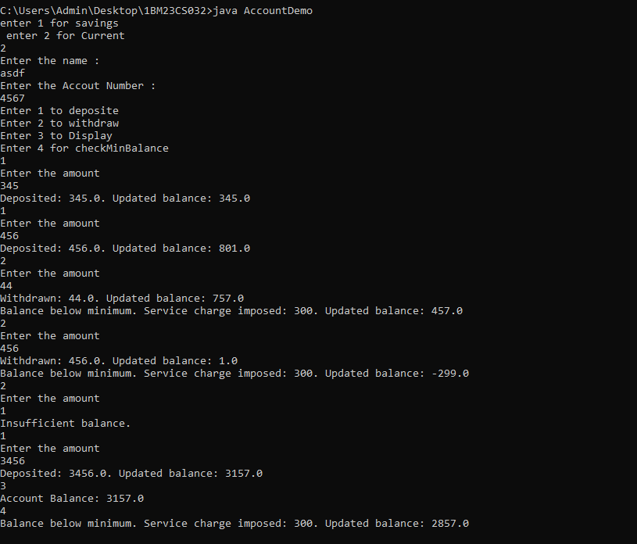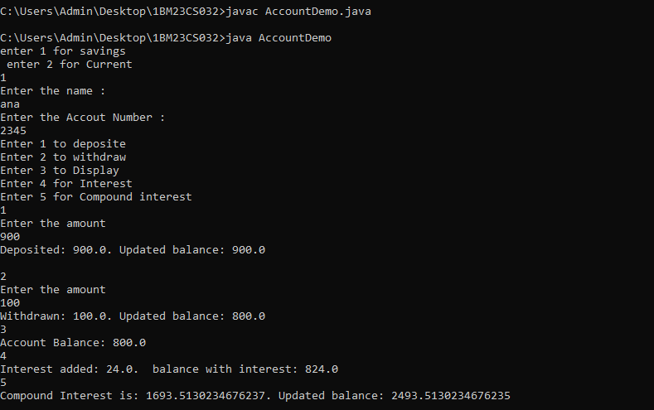

**Program 6**

Create a package CIE which has two classes- Student and Internals. The class Student has members like usn, name, sem. The class Internals derived from Student has an array that stores the internal marks scored in five courses of the current semester of the student. Create another package SEE which has the class External which is a derived class of Student. This class has an array that stores the SEE marks scored in five courses of the current semester of the student. Import the two packages in a file that declares the final marks of n students in all five courses.

Observations:

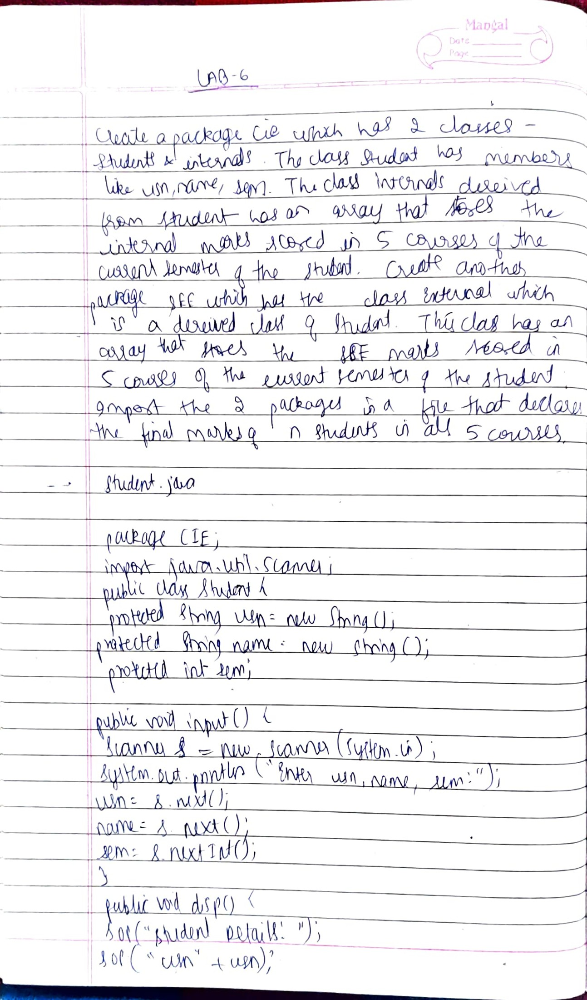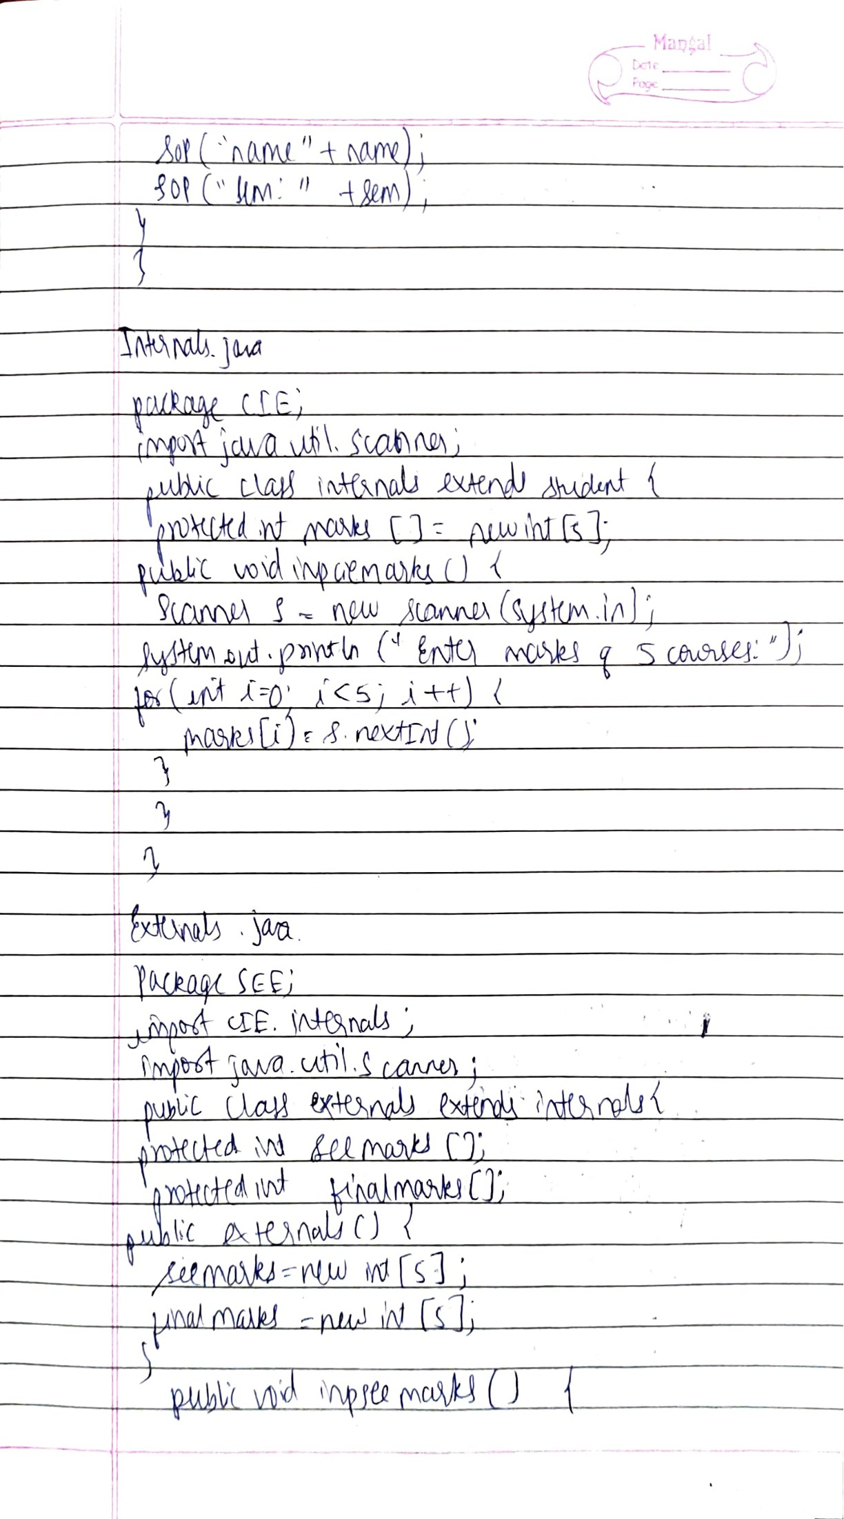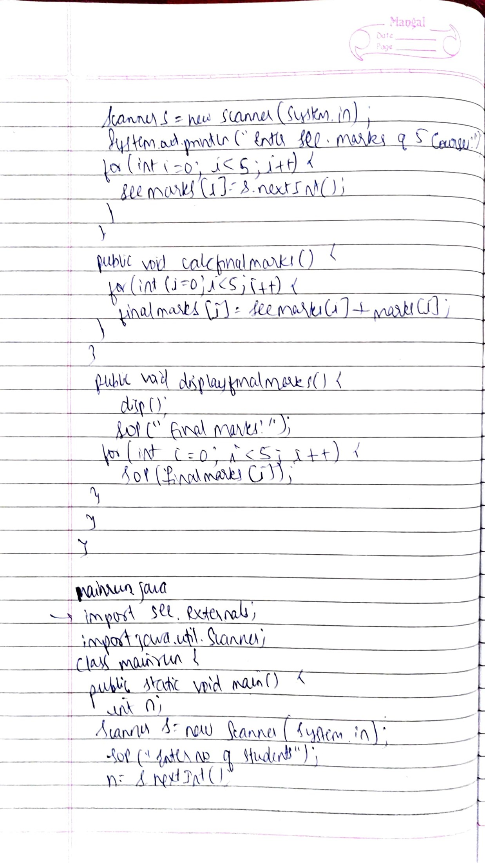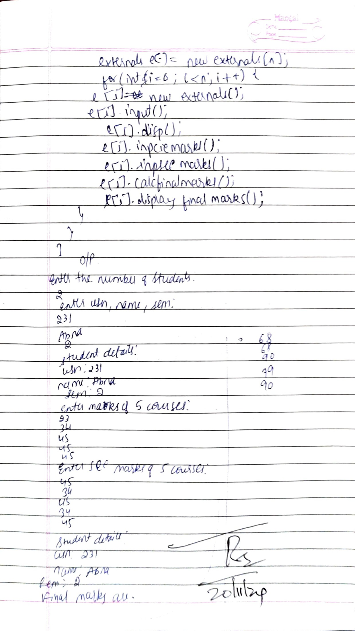

Code:

Student.java

package CIE;

import java.util.Scanner;

public class student {

protected String usn=new String();

protected String name=new String();

protected int sem;

public void input() {

Scanner s=new Scanner(System.in);

System.out.println("Enter usn, name, sem: ");

usn=s.next();

name=s.next();

sem=s.nextInt();

}

public void disp() {

System.out.println("Student Details: ");

System.out.println("usn: "+usn);

System.out.println("name: "+name);

System.out.println("sem: "+sem);

}

}

Internals.java

package CIE;

import java.util.Scanner;

public class internals extends student {

protected int marks[]=new int[5];

public void inpciemarks() {

Scanner s=new Scanner(System.in);

System.out.println("Enter marks of 5 courses: ");

for(int i=0;i<5;i++) {

marks[i]=s.nextInt();

}

}

}

Externals.java

package SEE;

import CIE.internals;

import java.util.Scanner;

public class externals extends internals {

protected int seemarks[];

protected int finalmarks[];

public externals() {

seemarks=new int[5];

finalmarks=new int[5];

}

public void inpseemarks() {

Scanner s= new Scanner(System.in);

System.out.println("Enter SEE marks of 5 courses: ");

for(int i=0;i<5;i++) {

seemarks[i]=s.nextInt();

}

}

public void calcfinalmarks() {

for(int i=0;i<5;i++) {

finalmarks[i]=seemarks[i]+marks[i];

}

}

public void displayfinalmarks() {

disp();

System.out.println("Final marks are: ");

for(int i=0;i<5;i++) {

System.out.println(finalmarks[i]);

}

}

}

Mainrun.java

import SEE.externals;

import java.util.Scanner;

class mainrun {

public static void main(String args[]) {

int n;

Scanner s=new Scanner(System.in);

System.out.println("Enter the number of students: ");

n=s.nextInt();

externals e[]=new externals[n];

for(int i=0;i<n;i++) {

e[i]=new externals();

e[i].input();

e[i].disp();

e[i].inpciemarks();

e[i].inpseemarks();

e[i].calcfinalmarks();

e[i].displayfinalmarks();

}

}

}

Output:

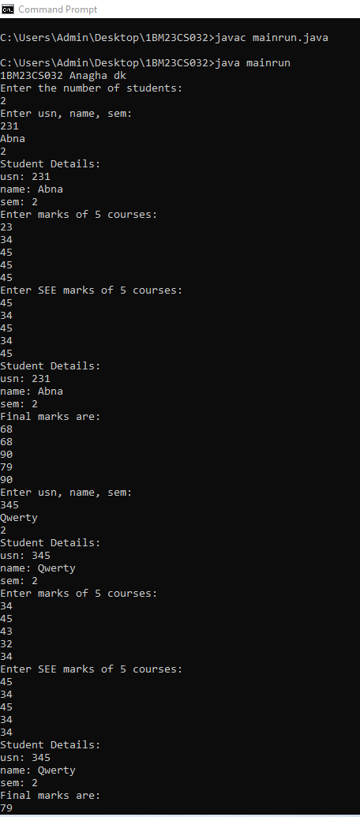

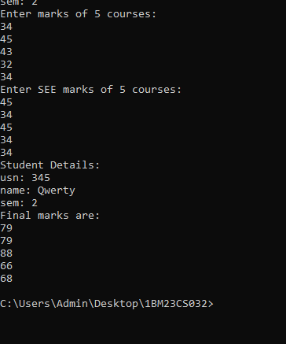

**Program 7**

Write a program that demonstrates handling of exception in a inheritance tree. Create a base class called Father and a derived class called Son which extends the base class. In Father’s class, implement a constructor which takes the age and throws an exception WrongAge when the input age is less than zero. In Son’s class, implement a constructor which uses father’s age and son’s age and throws an exception if son’s age is greater than father’s age.

Observations:

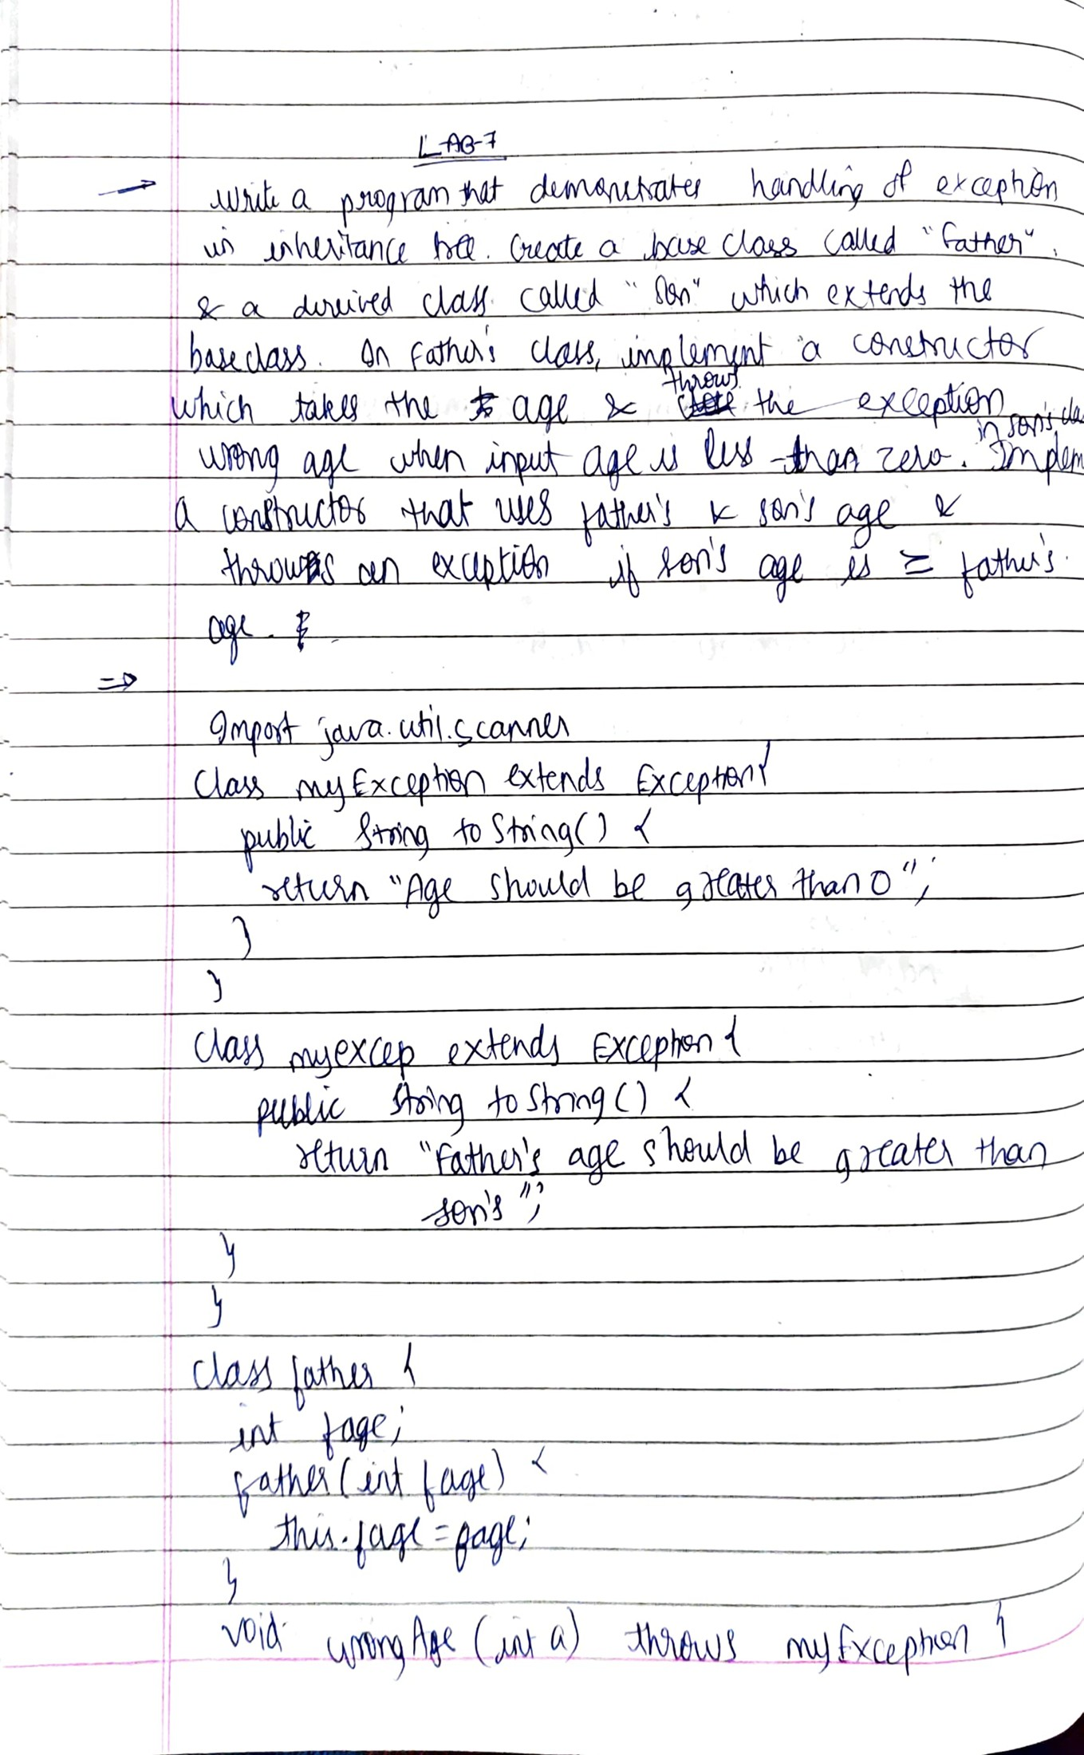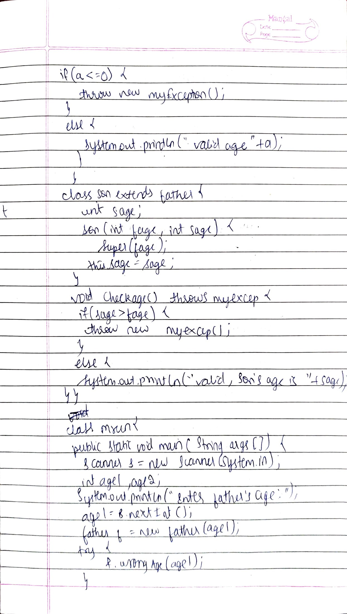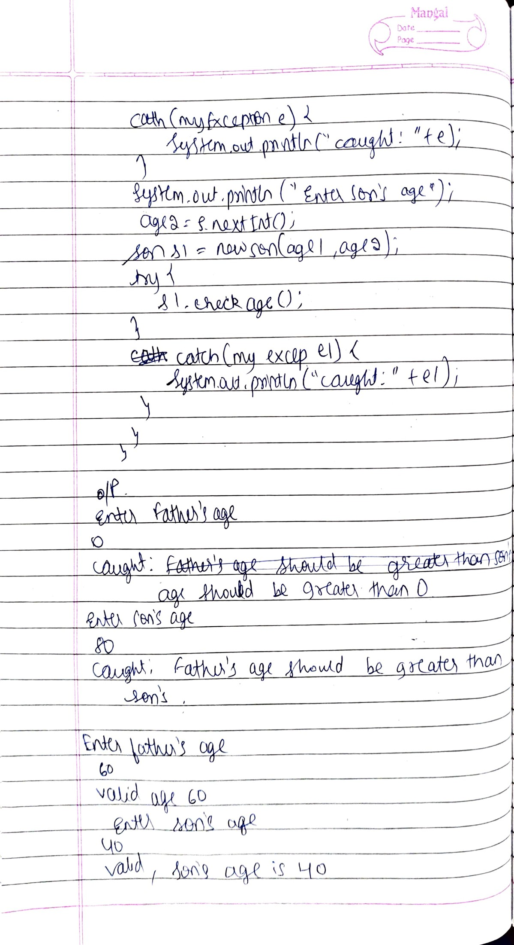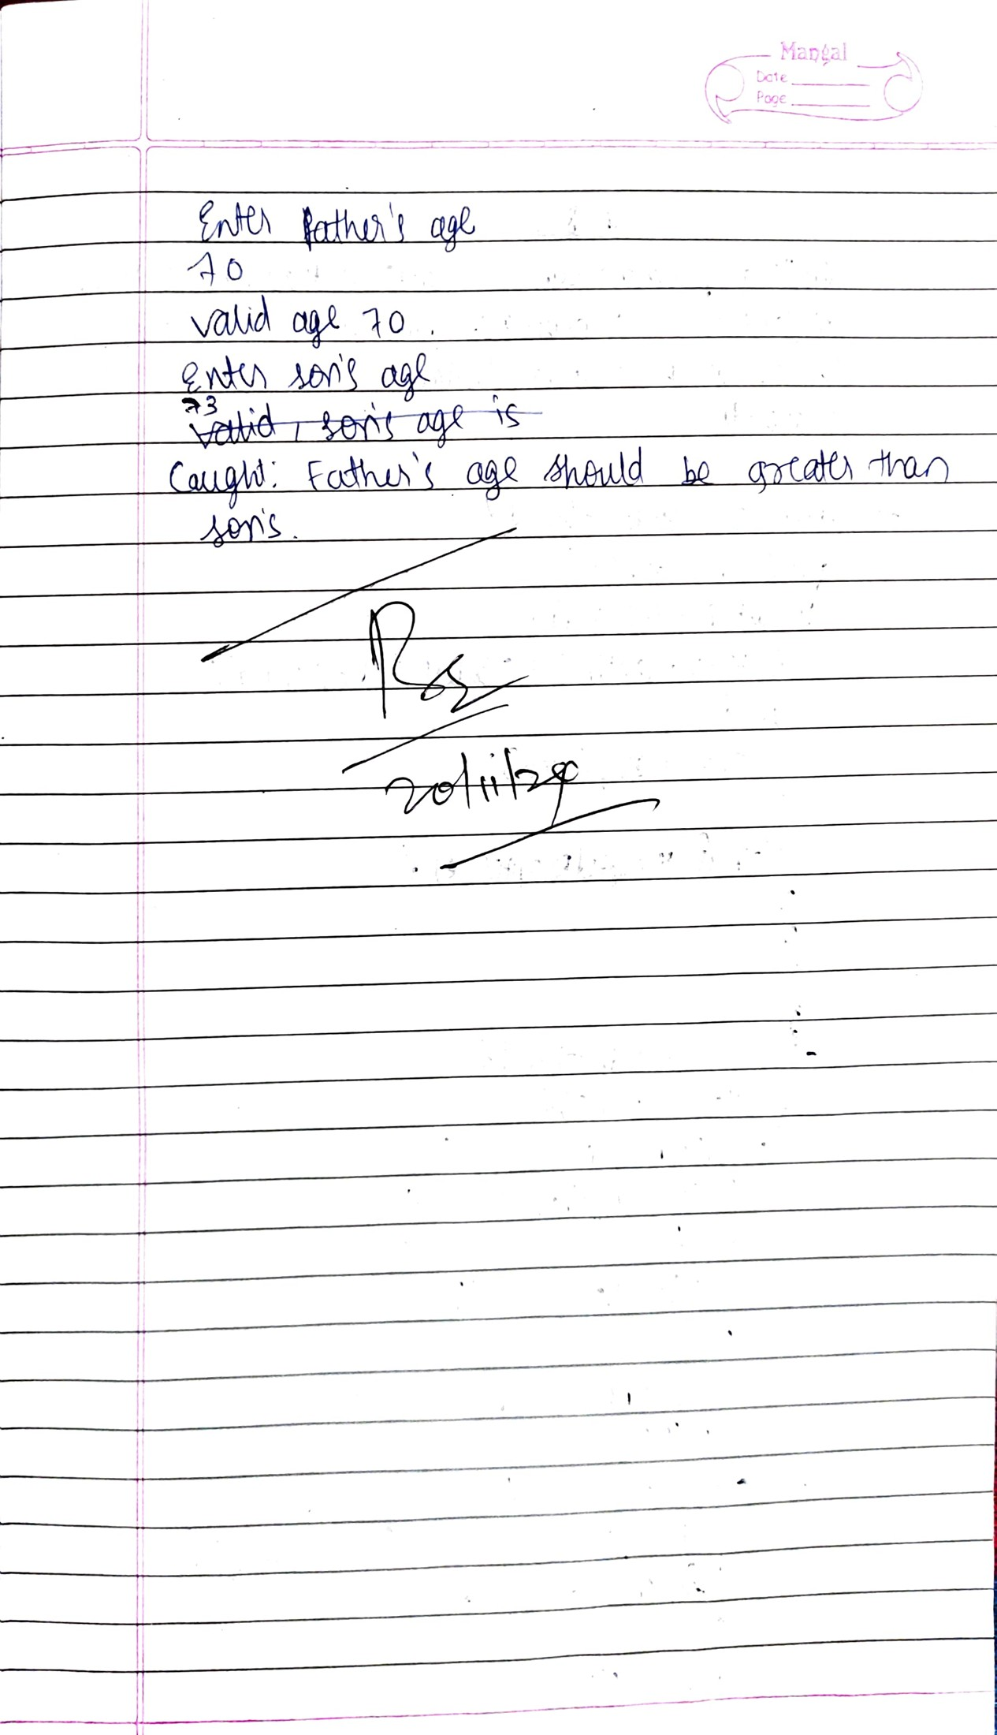

Code:

import java.util.Scanner;

class myException extends Exception{

public String toString() {

return "Age should be greater than zero";

}

}

class myexcep extends Exception{

public String toString() {

return "Father's age should be greater than son's";

}

}

class father {

int fage;

father(int fage) {

this.fage=fage;

}

void wrongAge(int a) throws myException {

if(a<=0) {

throw new myException();

}

else{

System.out.println("Valid Age "+a);

}

}

void disp() {

System.out.println("Father's age is: "+fage);

}

}

class son extends father{

int sage;

son(int fage, int sage) {

super(fage);

this.sage=sage;

}

void checkage() throws myexcep {

if(sage>fage) {

throw new myexcep();

}

else

{

System.out.println("Valid, Son's age is "+sage);

}}

void disp2() {

System.out.println("Son's age is: "+sage);

}

}

class mrun{

public static void main(String args[]) {

Scanner s=new Scanner(System.in);

int age1,age2;

System.out.println("Anagha D K, 1BM23CS032");

System.out.println("Enter the Father's age");

age1=s.nextInt();

father f=new father(age1);

try{

f.wrongAge(age1);

}

catch(myException e){

System.out.println("Caught: "+e);

}

System.out.println("Enter the Son's age");

age2=s.nextInt();

son s1=new son(age1,age2);

try{

s1.checkage();

}

catch(myexcep e1){

System.out.println("Caught: "+e1);

}

}

}

Output:

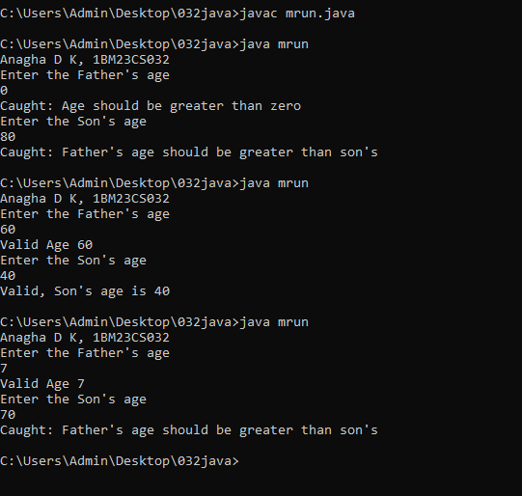

**Program 8**

Write a program which creates two threads, one thread displaying “BMS College of Engineering” once every ten seconds and another displaying “CSE” once every two seconds.

Code:

Observations:

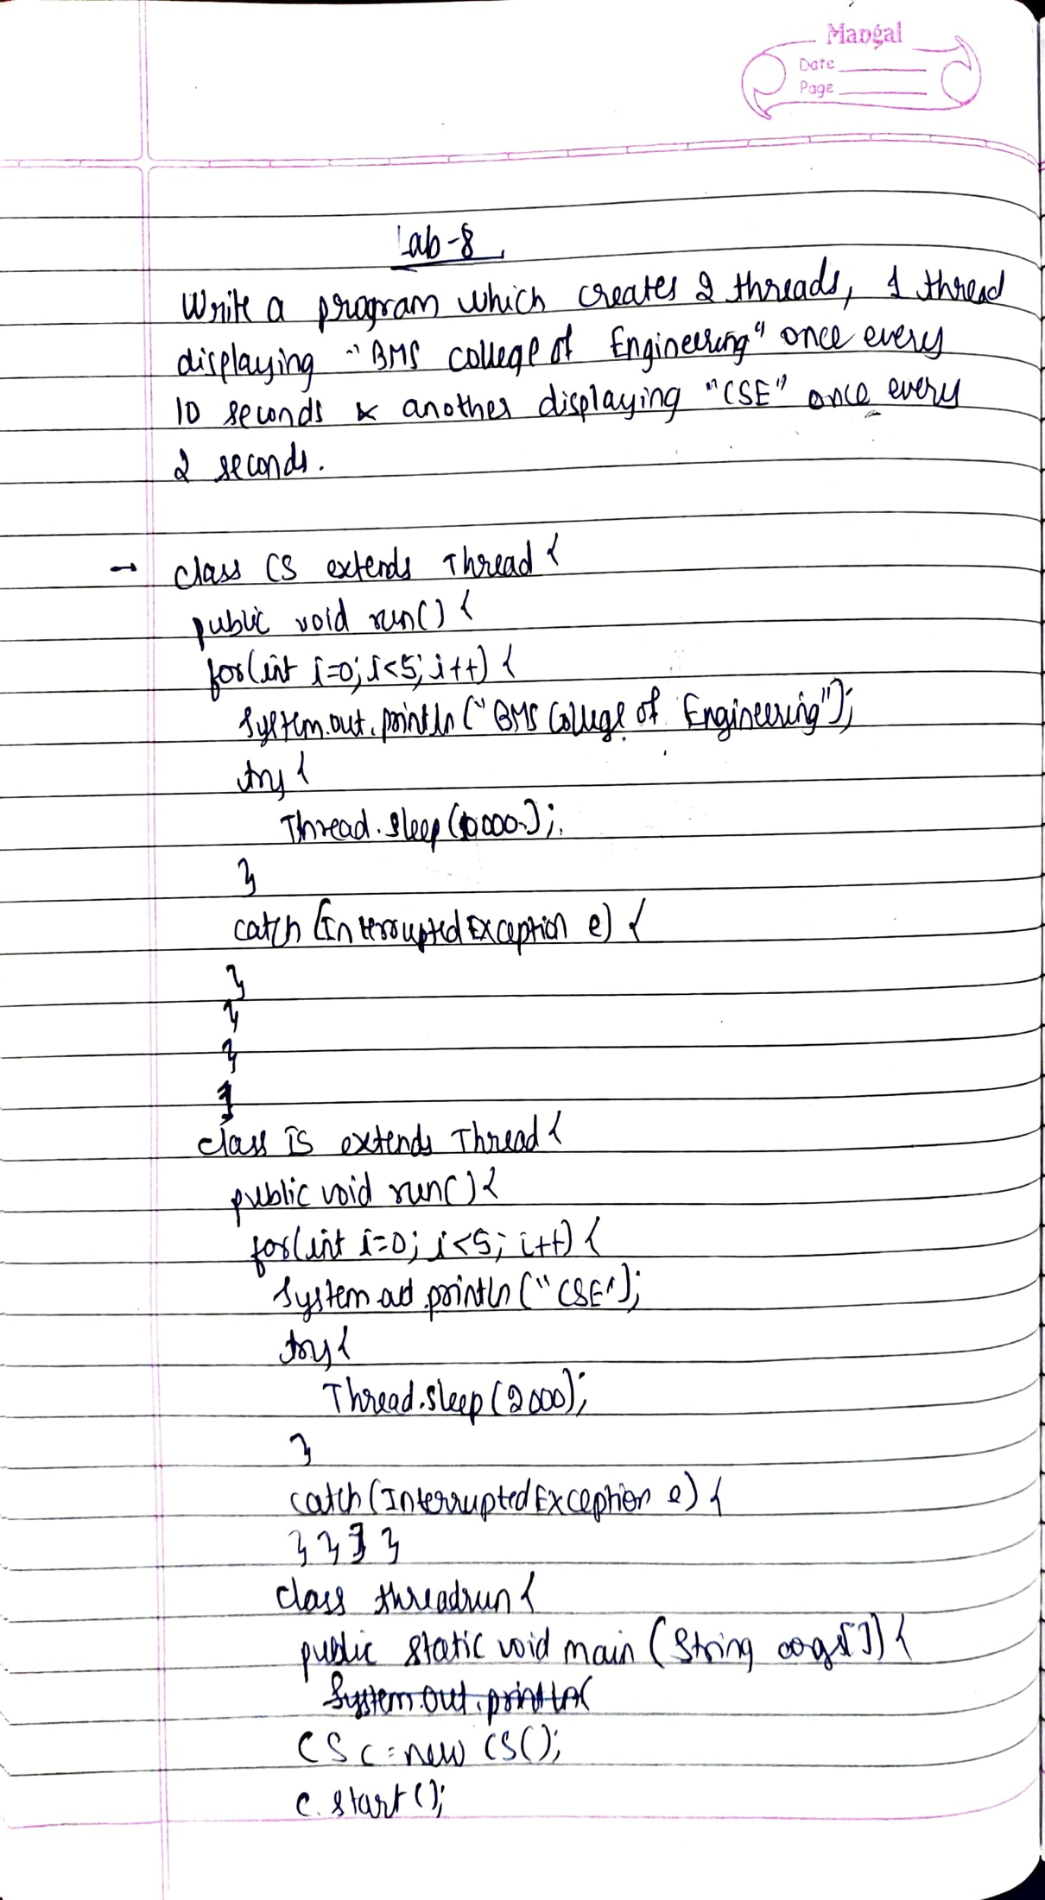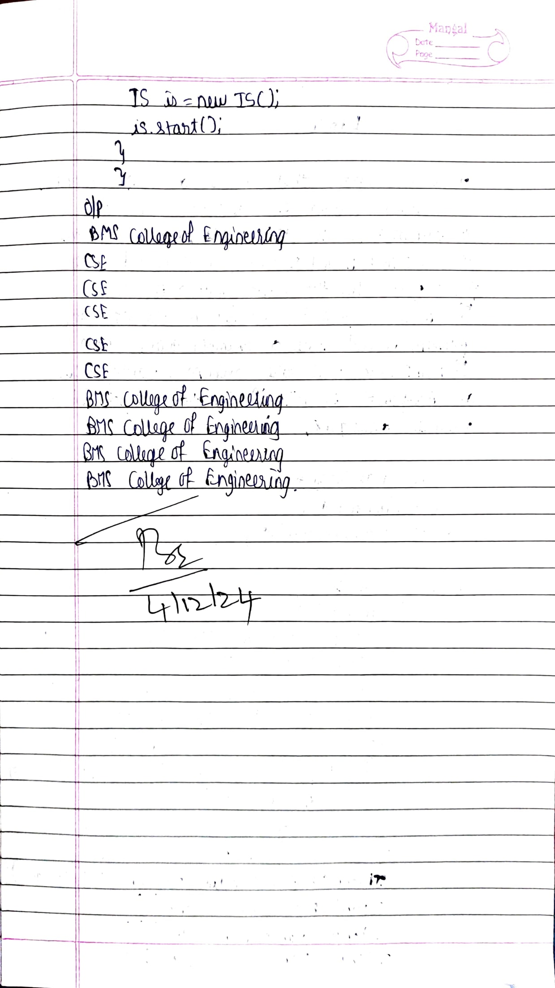

(Using extends keyword)

class CS extends Thread {

public void run() {

for(int i=0;i<5;i++) {

System.out.println("BMS College of Engineering");

try {

Thread.sleep(10000);

}

catch(InterruptedException e) {

}

}

}

}

class IS extends Thread {

public void run() {

for(int i=0;i<5;i++) {

System.out.println("CSE");

try {

Thread.sleep(2000);

}

catch(InterruptedException e) {

}

}

}

}

class threadrun {

public static void main(String args[]) {

System.out.println("Anagha D K 1BM23CS032");

CS c=new CS();

c.start();

IS is=new IS();

is.start();

}

}

(Using implements keyword)

class CS implements Runnable {

public void run() {

for(int i=0;i<5;i++) {

System.out.println("BMS College of Engineering");

try {

Thread.sleep(10000);

}

catch(InterruptedException e) {

}

}

}

}

class IS implements Runnable {

public void run() {

for(int i=0;i<5;i++) {

System.out.println("CSE");

try {

Thread.sleep(2000);

}

catch(InterruptedException e) {

}

}

}

}

class threadr {

public static void main(String args[]) {

System.out.println("Anagha D K 1BM23CS032");

CS c=new CS();

Thread th=new Thread(c);

th.start();

IS is=new IS();

Thread th2=new Thread(is);

th2.start();

}

}

Output:

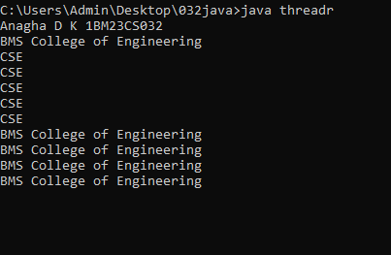

**Program 9**

Write a program that creates a user interface to perform integer divisions. The user enters two numbers in the text fields, Num1 and Num2. The division of Num1 and Num2 is displayed in the Result field when the Divide button is clicked. If Num1 or Num2 were not an integer, the program would throw a NumberFormatException. If Num2 were Zero, the program would throw an Arithmetic Exception Display the exception in a message dialog box.

Observations:

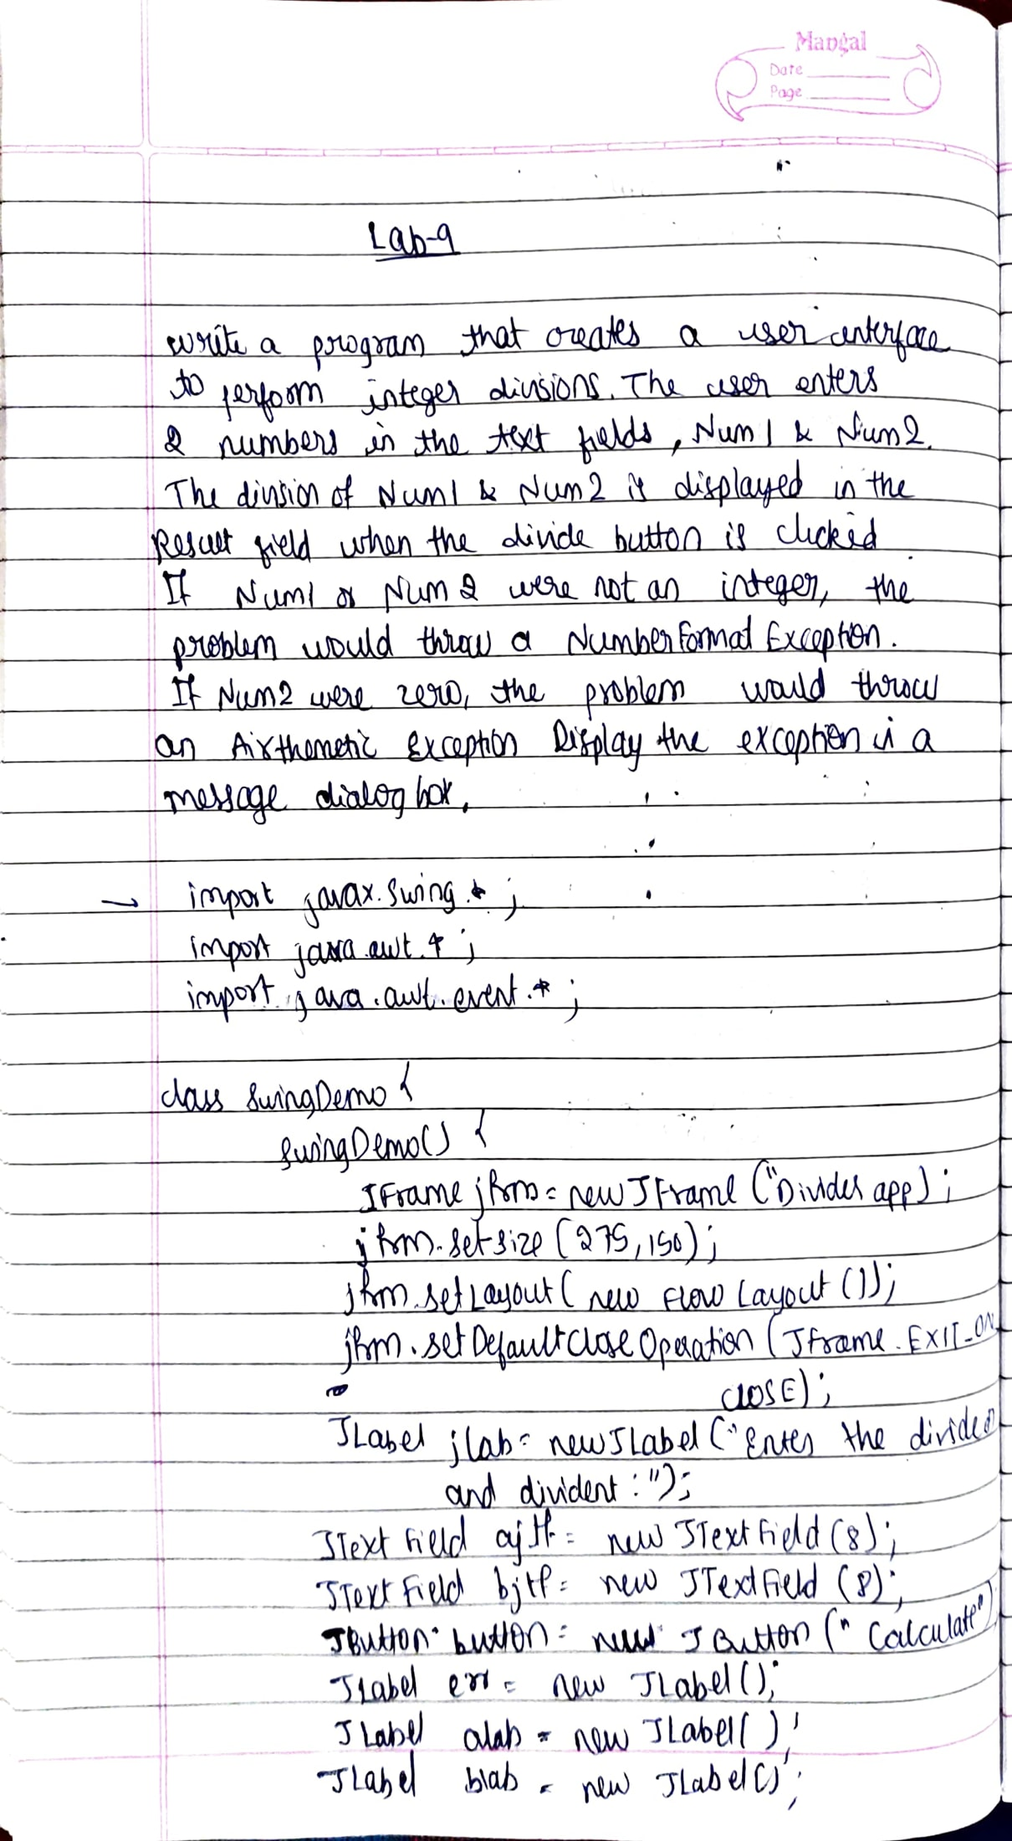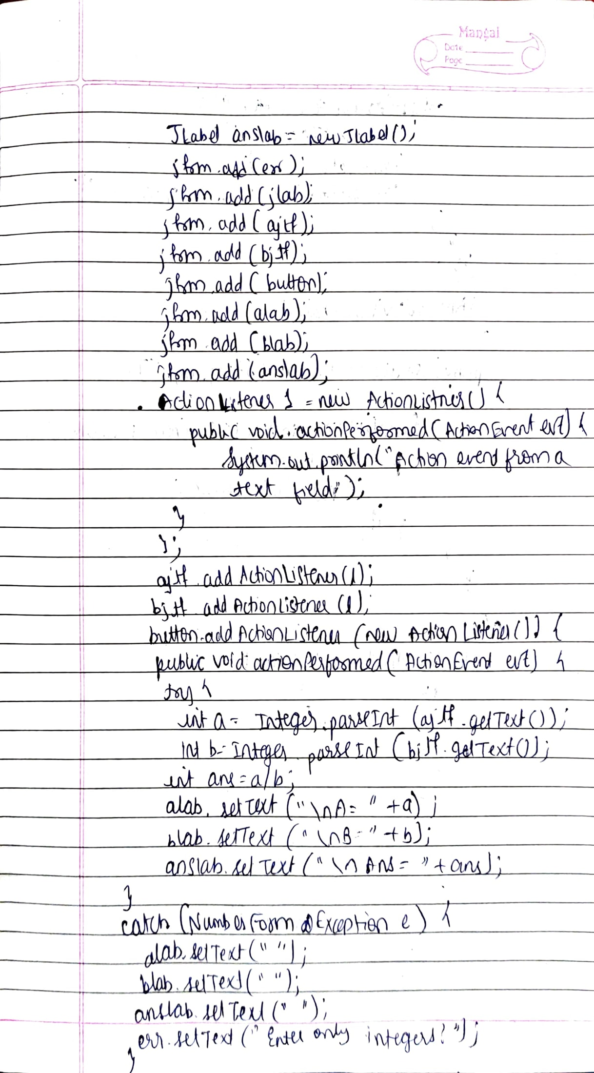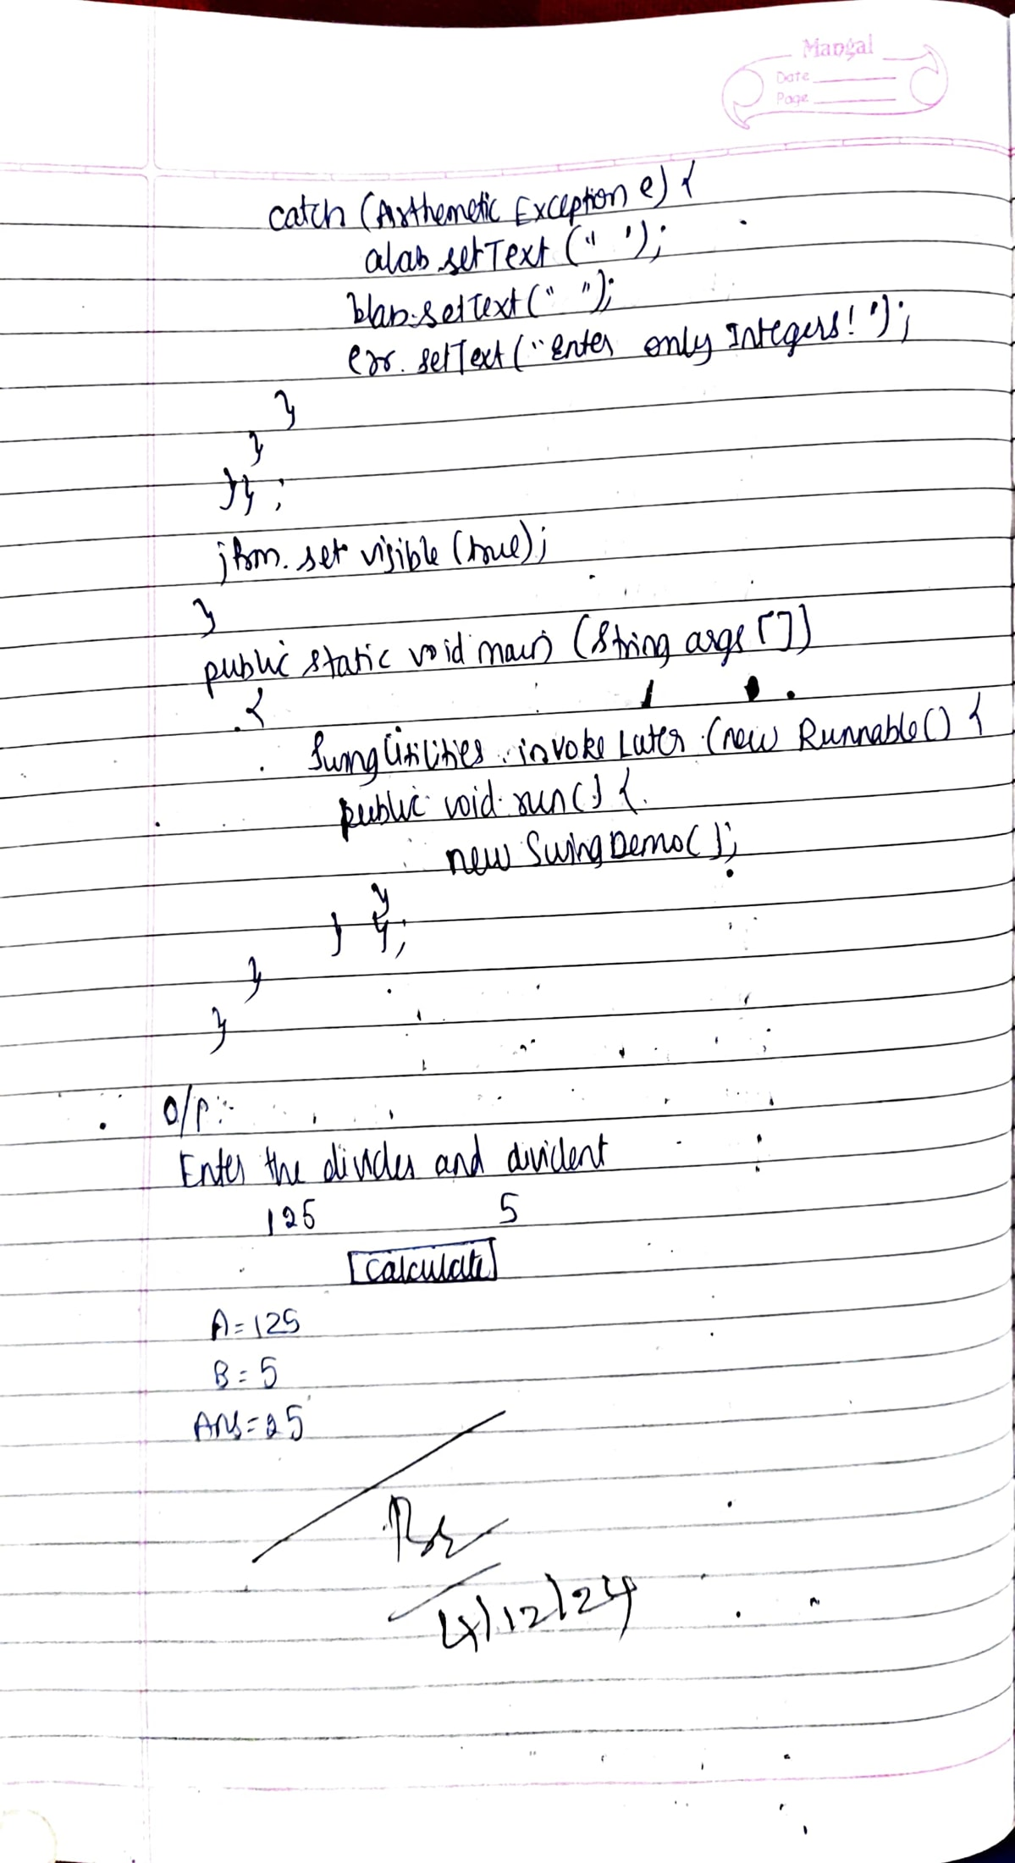

Code:

class Q {

int n;

boolean valueSet = false;

synchronized int get() {

while(!valueSet)

try {

System.out.println("\nConsumer waiting\n");

wait();

} catch(InterruptedException e) {

System.out.println("InterruptedException caught");

}

System.out.println("Got: " + n);

valueSet = false;

System.out.println("\nIntimate Producer\n");

notify();

return n;

}

synchronized void put(int n) {

while(valueSet)

try {

System.out.println("\nProducer waiting\n");

wait();

} catch(InterruptedException e) {

System.out.println("InterruptedException caught");

}

this.n = n;

valueSet = true;

System.out.println("Put: " + n);

System.out.println("\nIntimate Consumer\n");

notify();

}

}

class Producer implements Runnable {

Q q;

Producer(Q q) {

this.q = q;

new Thread(this, "Producer").start();

}

public void run() {

int i = 0;

while(i<15) {

q.put(i++);

}

}

}

class Consumer implements Runnable {

Q q;

Consumer(Q q) {

this.q = q;

new Thread(this, "Consumer").start();

}

public void run() {

int i=0;

while(i<15) {

int r=q.get();

System.out.println("consumed:"+r);

i++;

}

}

}

class PCFixed {

public static void main(String args[]) {

Q q = new Q();

new Producer(q);

new Consumer(q);

System.out.println("Press Control-C to stop.");

}

}

Output:

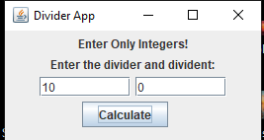

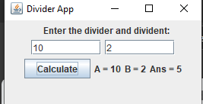

**Program 10**

Demonstrate Inter process Communication and deadlock

Observations:

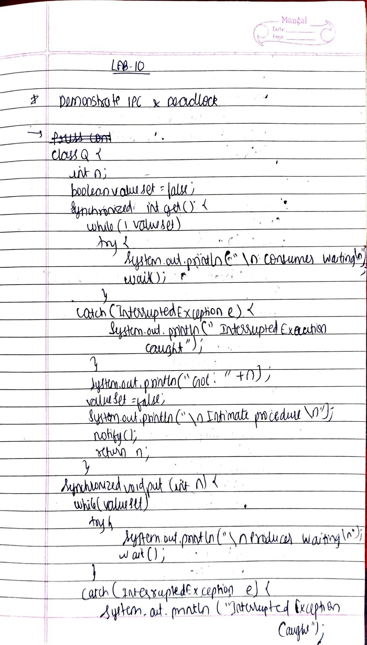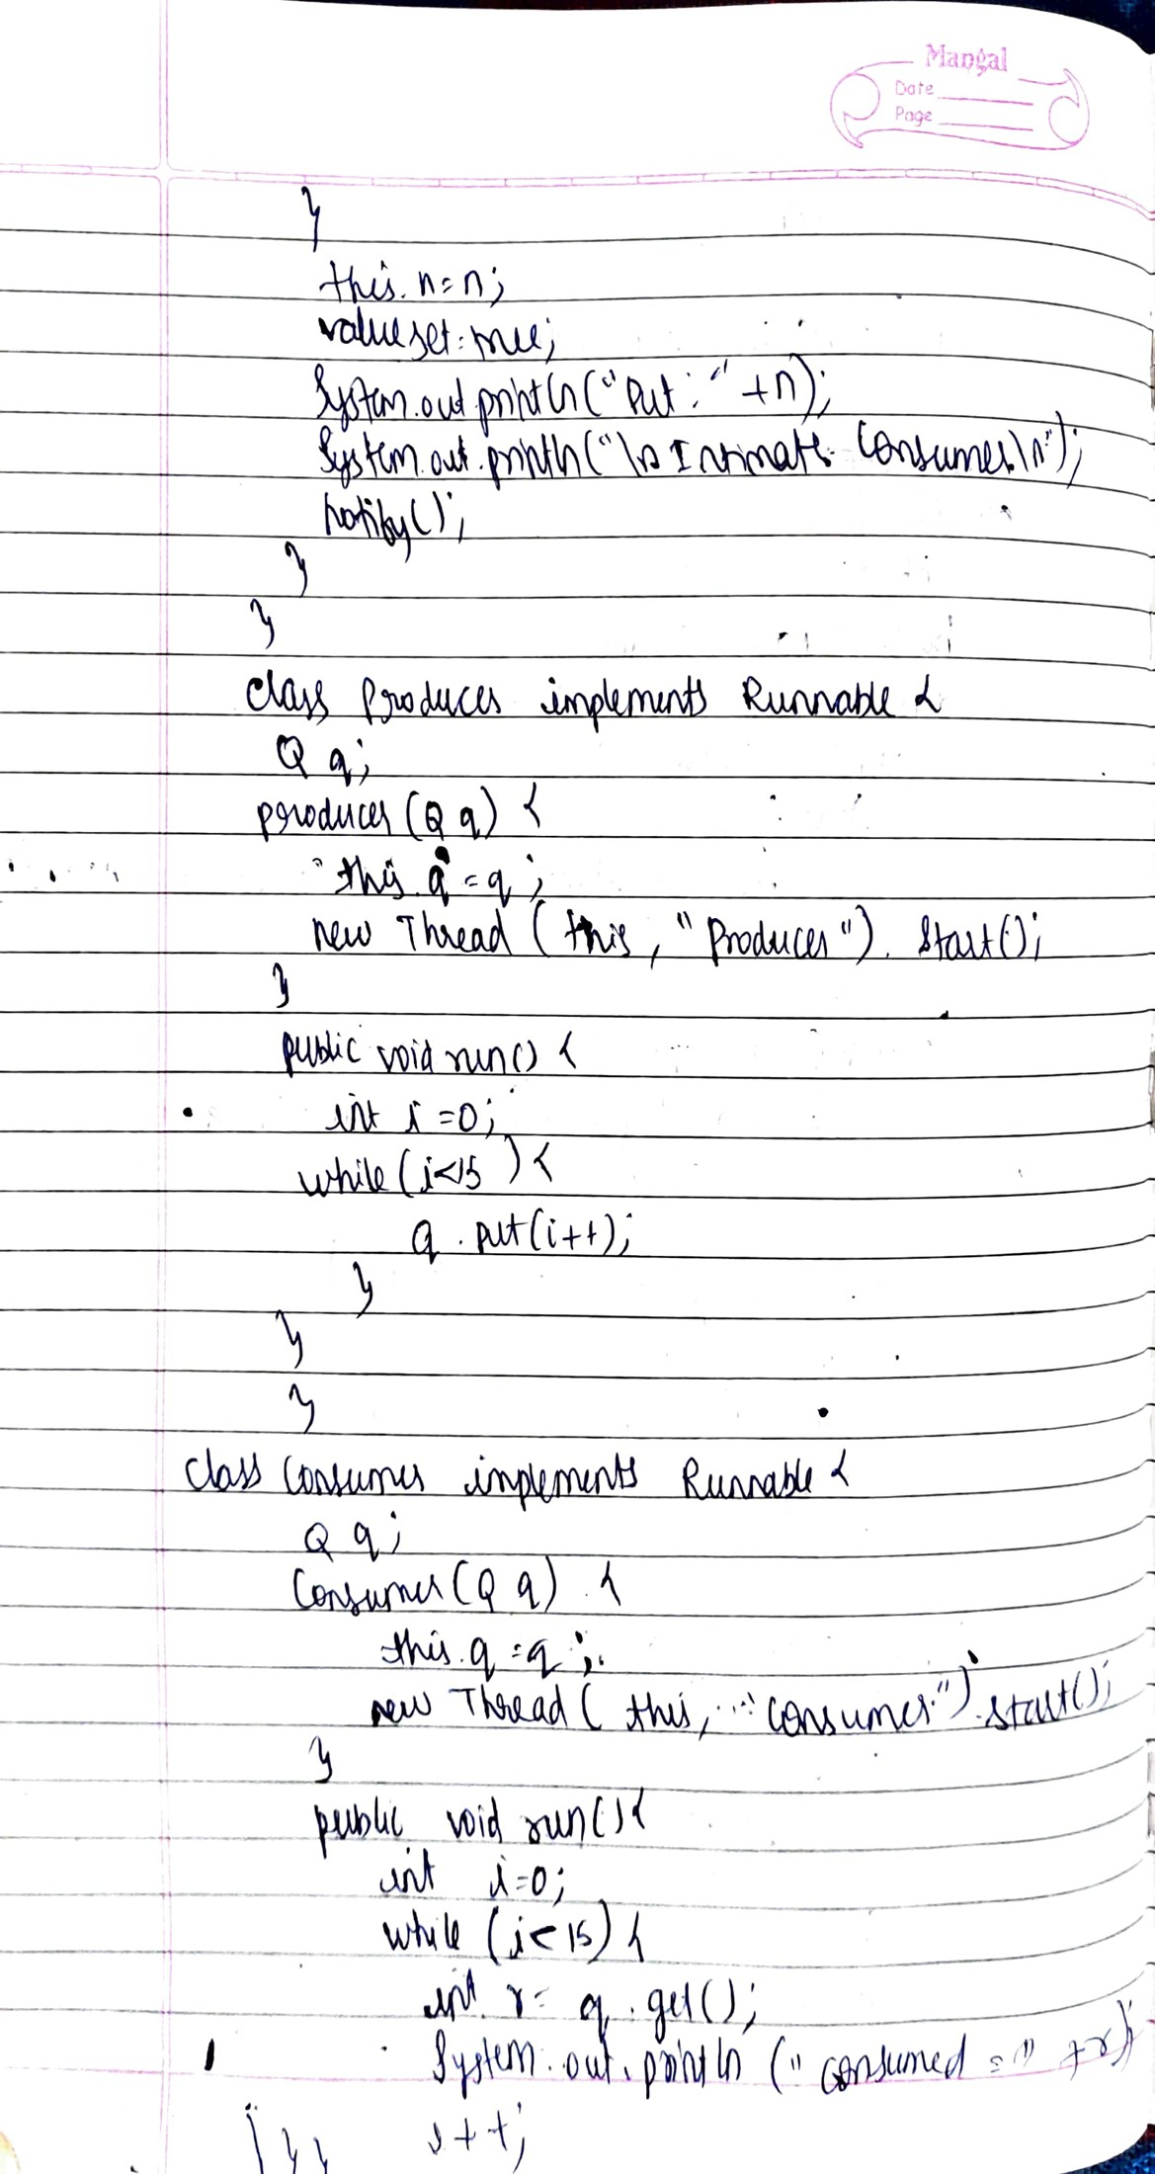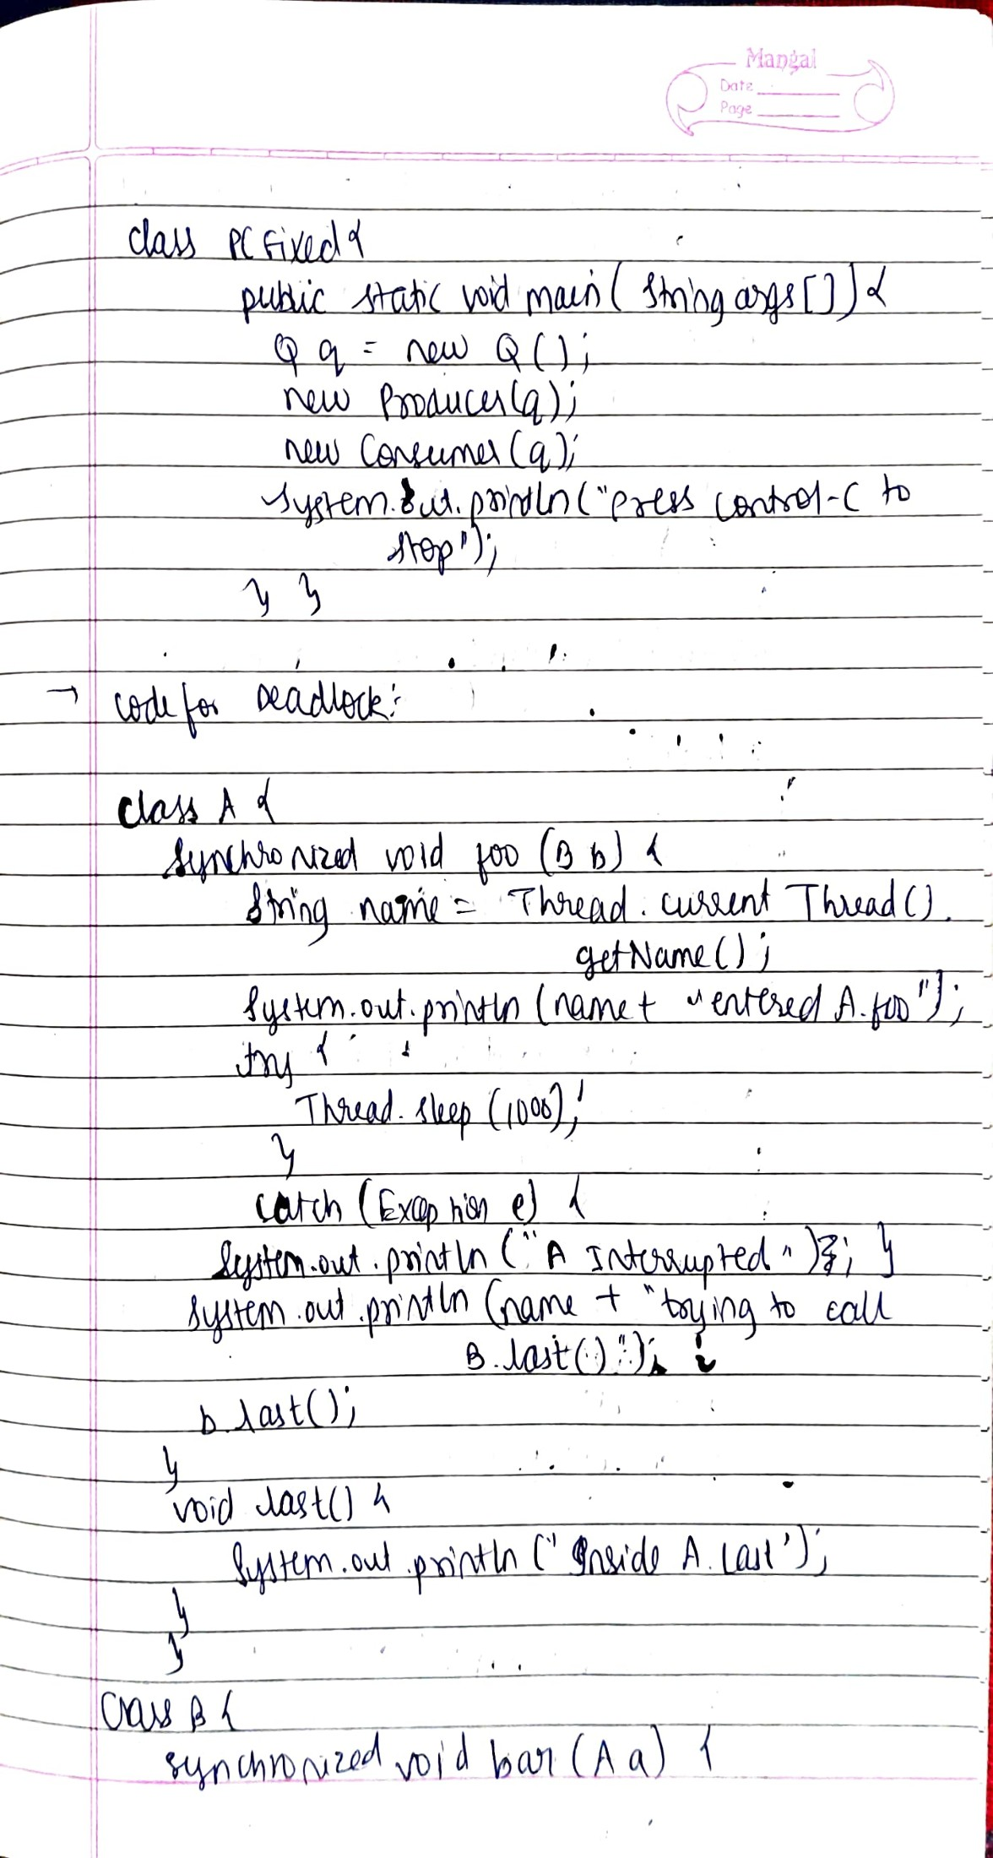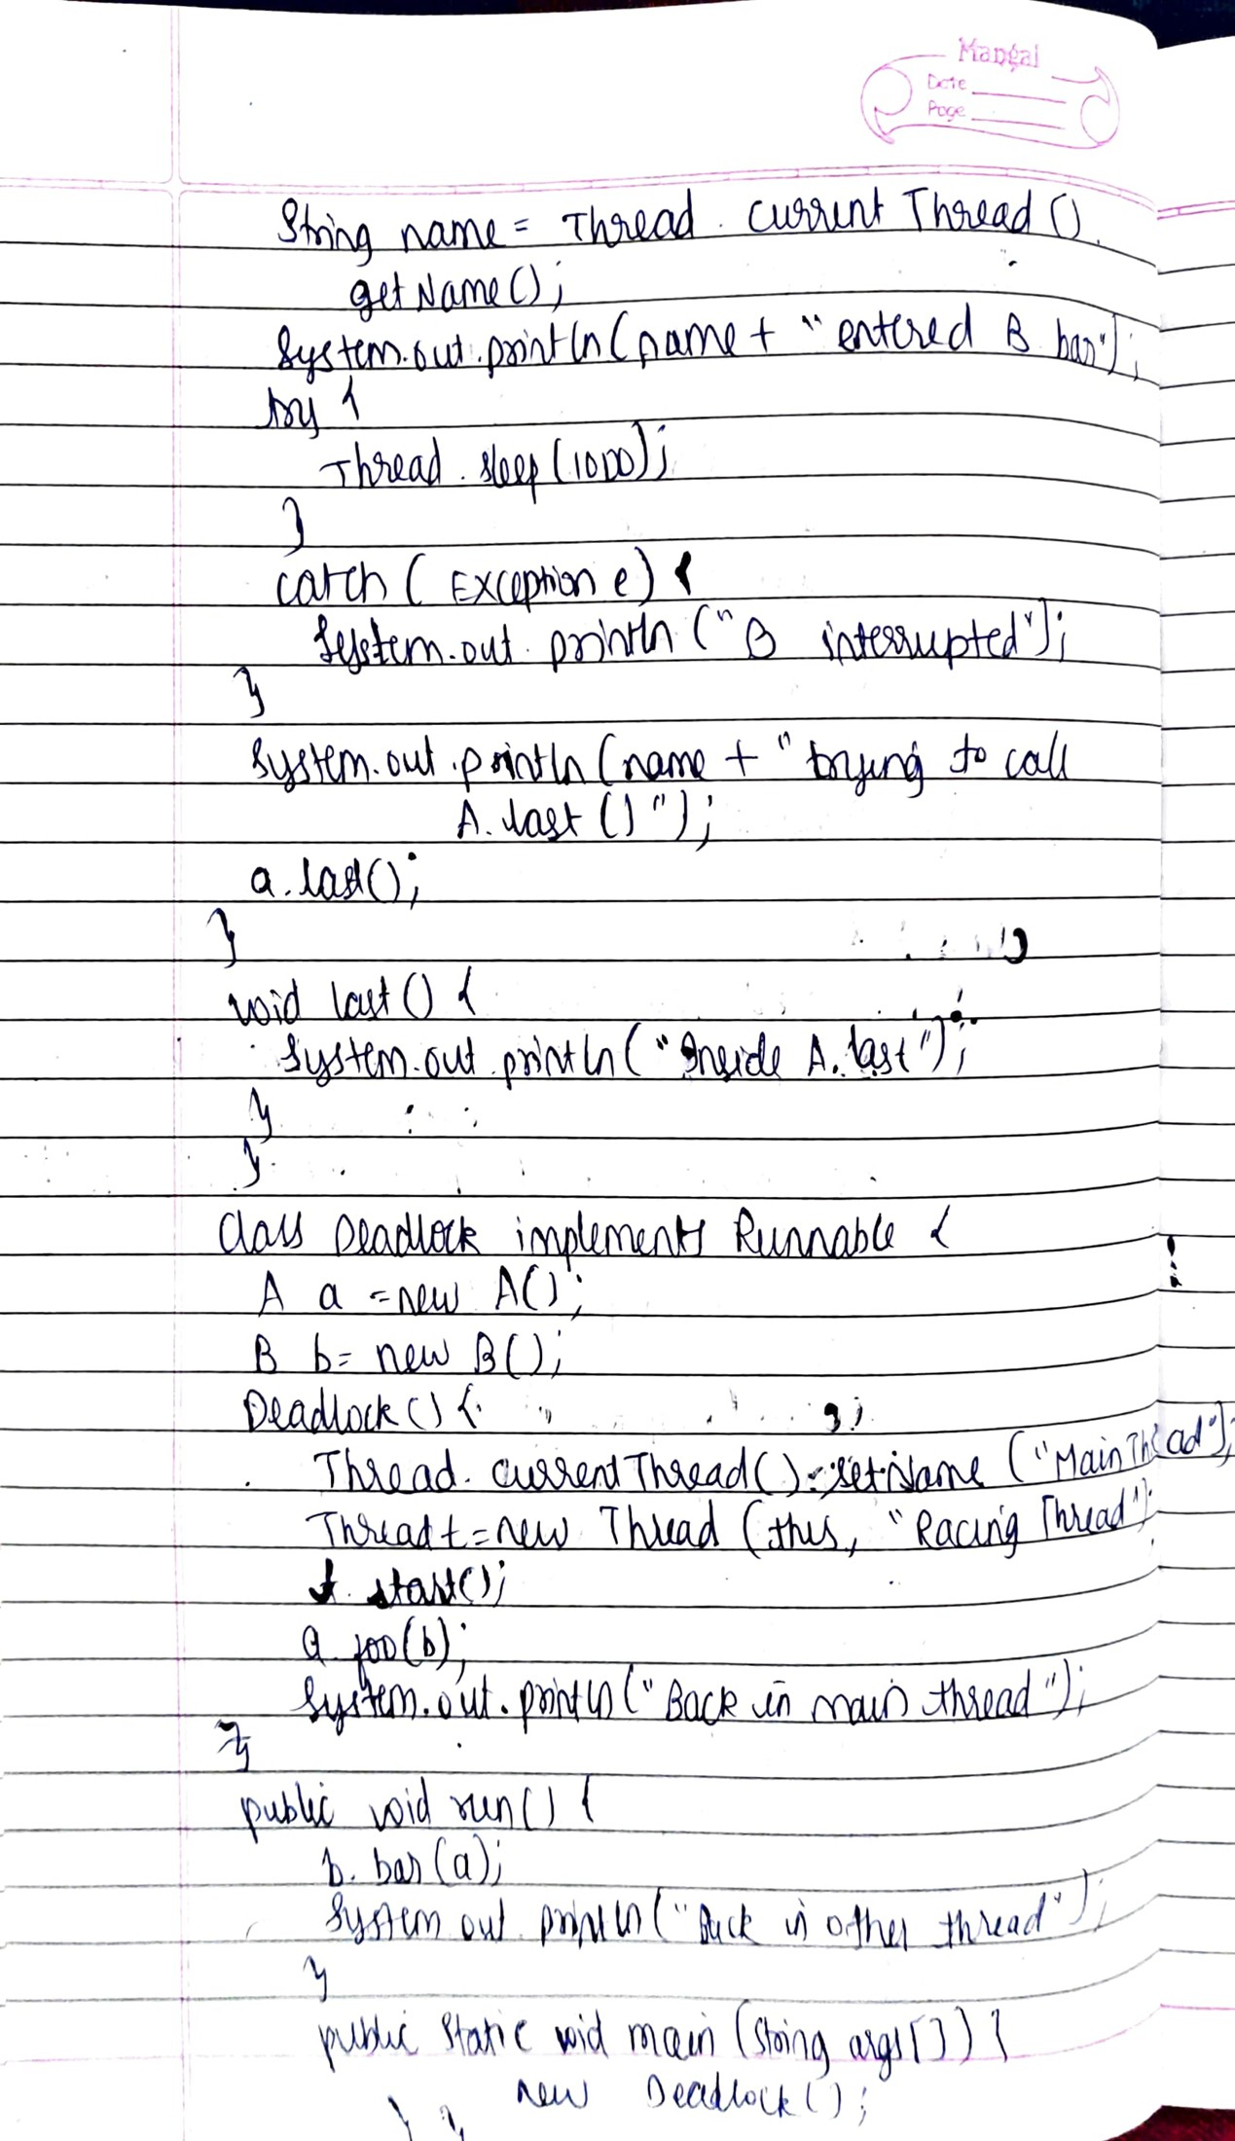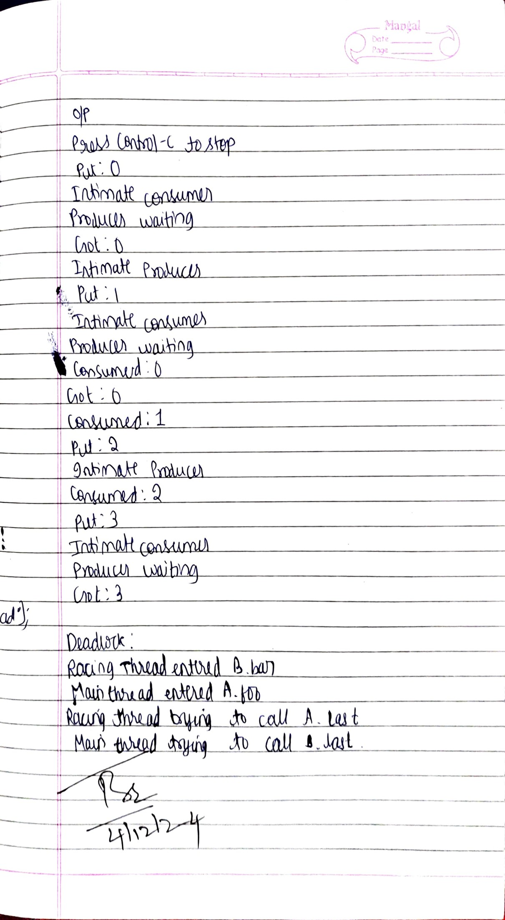

Code:

class A {

synchronized void foo(B b) {

String name =Thread.currentThread().getName();

System.out.println(name + " entered A.foo");

try {

Thread.sleep(1000);

} catch(Exception e) {

System.out.println("A Interrupted");

}

System.out.println(name + " trying to call B.last()");

b.last();

}

void last() {

System.out.println("Inside A.last");

}

}

class B {

synchronized void bar(A a) {

String name =Thread.currentThread().getName();

System.out.println(name + " entered B.bar");

try {

Thread.sleep(1000);

} catch(Exception e) {

System.out.println("B Interrupted");

}

System.out.println(name + " trying to

call A.last()");

a.last();

}

void last() {

System.out.println("Inside A.last");

}

}

class Deadlock implements Runnable

{

A a = new A();

B b = new B();

Deadlock() {

Thread.currentThread().setName("MainThread");

Thread t = new Thread(this, "RacingThread");

t.start();

a.foo(b); // get lock on a in thisthread.

System.out.println("Back in main thread");

}

public void run() {

b.bar(a); // get lock on b in other thread.

System.out.println("Back in other thread");

}

public static void main(String args[]) {

new Deadlock(); }}

Output:

